

# CL219 – Database Systems Lab

**Spring 2020, BS (CS-2018)**

Instructor: Ma’am Saba Naseem

Project

*Focus Logics* COVID-19 Management System

**Group members**

|  |  |  |
| --- | --- | --- |
| **Name** | **Roll no.** | **Section** |
| Abdul Wahab | 18F-0121 | C |
| Rizwan Ali | 18F-0106 | C |
| Rameez Ahmed | 18F-0323 | C |

**National University of Computer & Emerging Sciences –FAST (FSD)**

1. **Screenshots:**

**Patients Entity:**

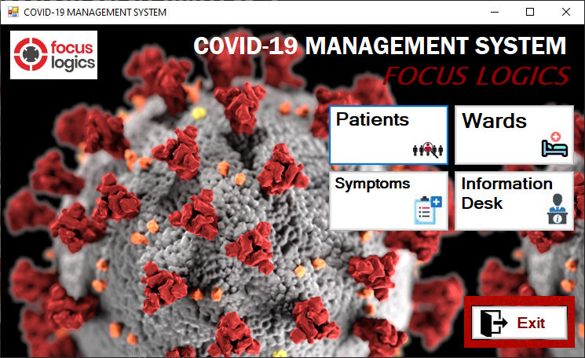

On Clicking ***“Focus Logics”***. It displays objectives.

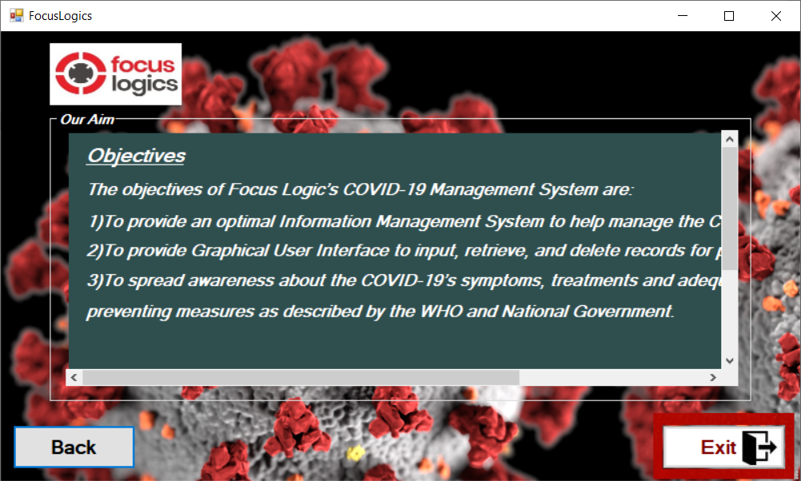

On Clicking ***“Patients Entity”***. It displays main patient functionalities.

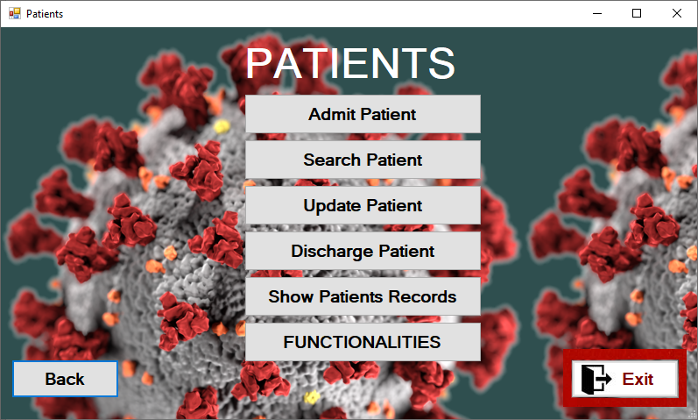

On Clicking ***“Admit Patient”***. It displays Patient admit form with combo box ward type selection and check box symptom selection.

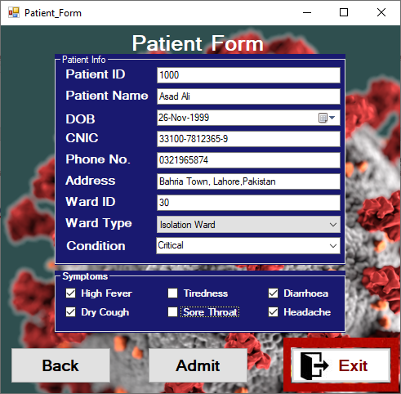

On Clicking ***“Admit Patient”***. It contains necessary referential integrity constraints (checks) to verify if the desired ward exists or not.

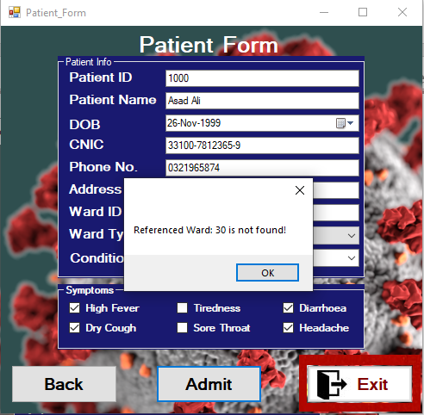

Now the referenced ward exists.

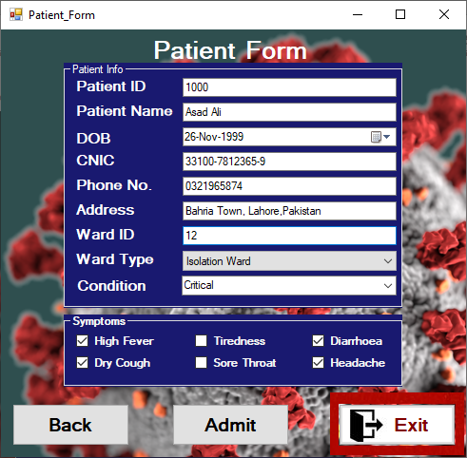

On admitting patient, ***“expose to”*** form appears to enter the areas and people the specific patient is exposed to. This can be helpful for contact tracing and smart lockdown.

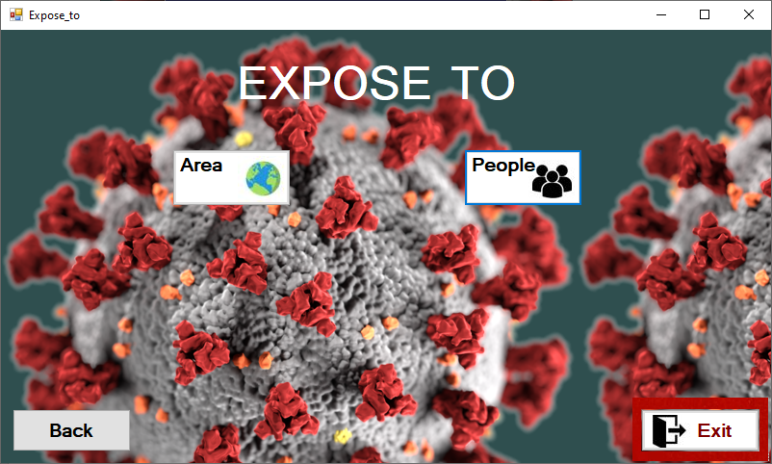

Area exposed form with necessary search, insert and display query.

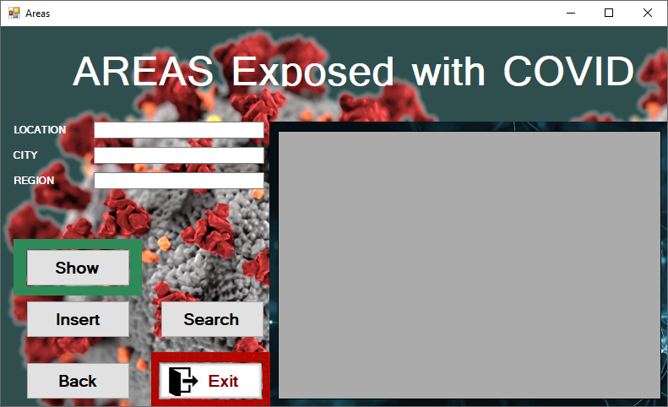

Show query.

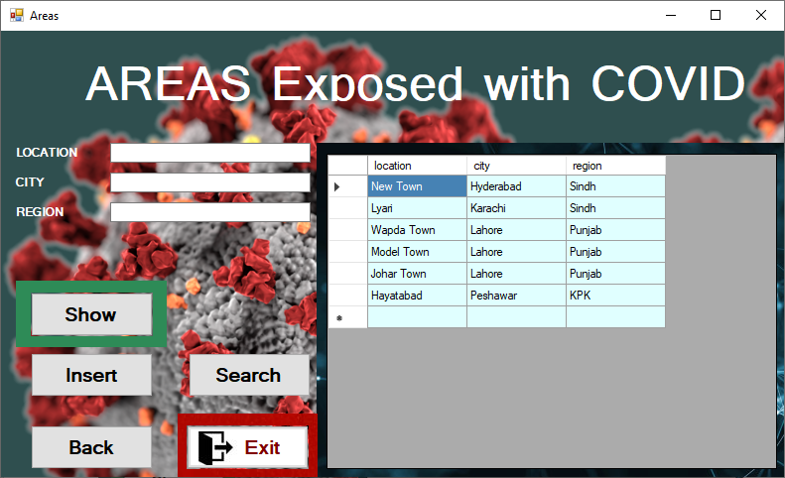

Search query, On the basis any given attribute.

(i.e. search on location)

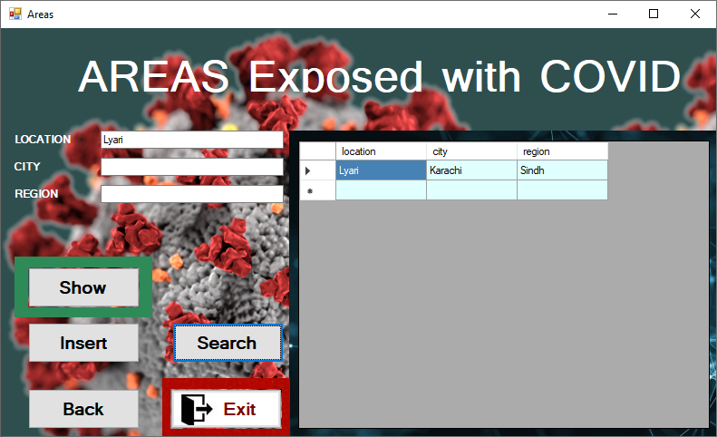

(i.e. search on City)

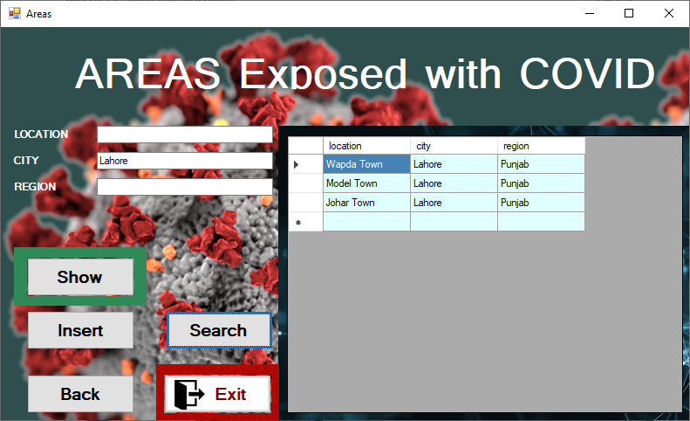

(i.e. search on Region)

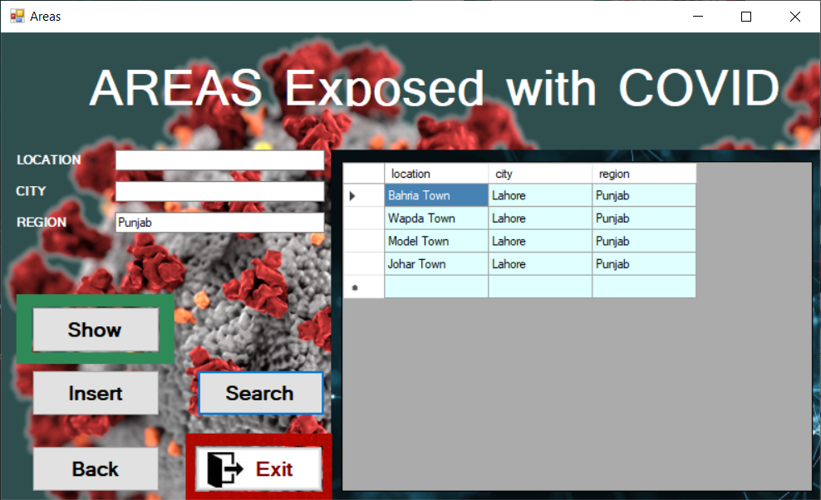

Insert query.

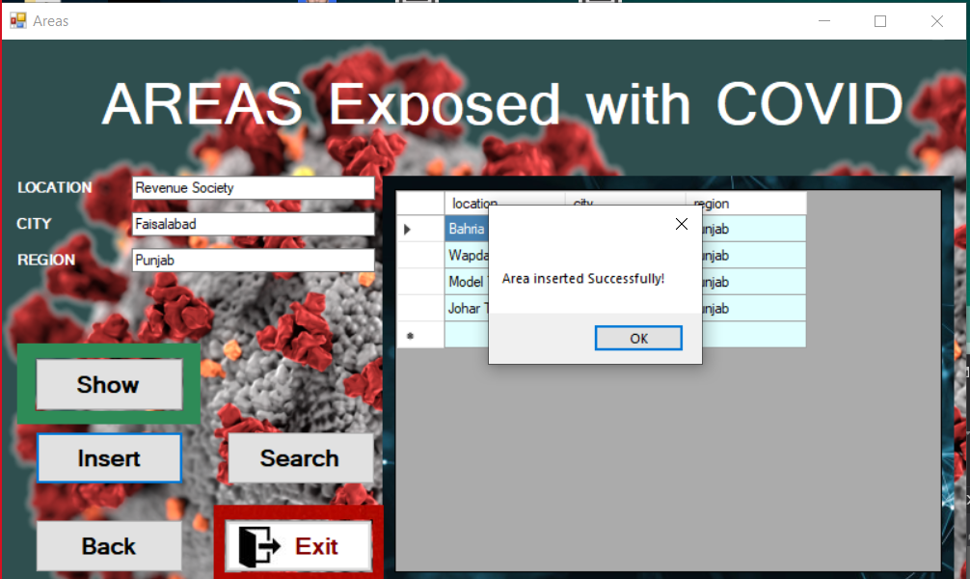

Check to insure all fields are filled.

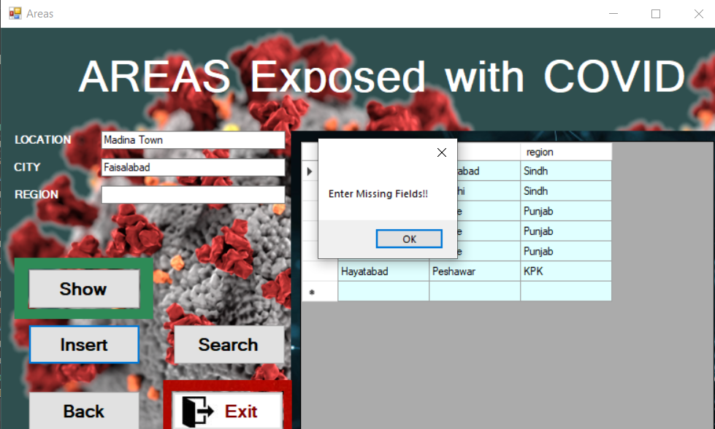

Show query.

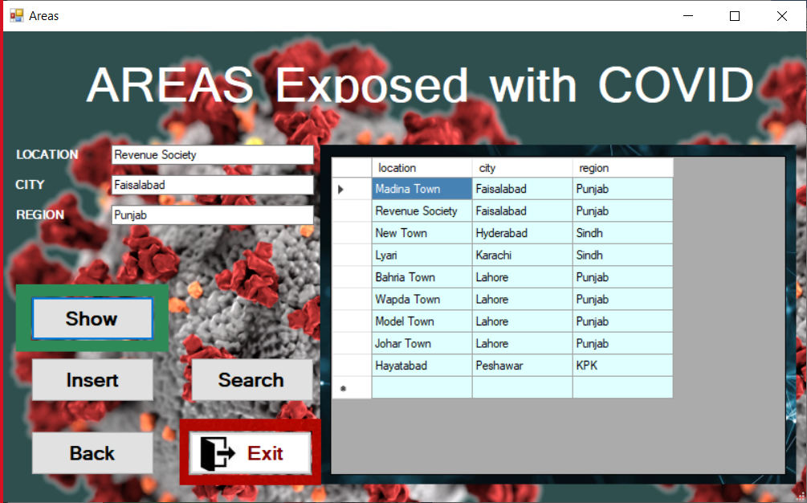

**Insert** query on **“People exposed form”.**

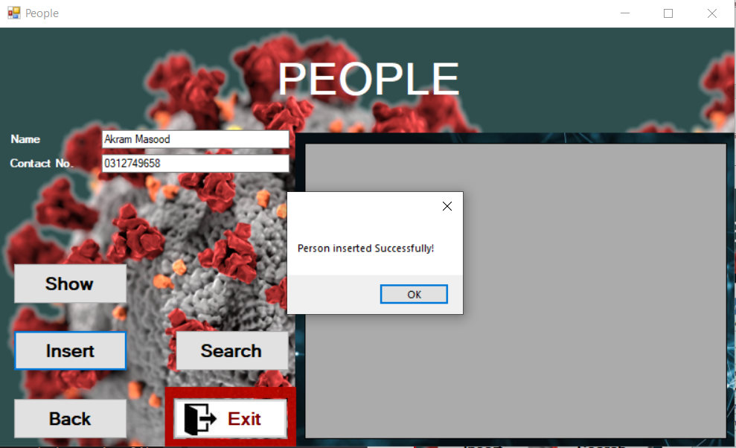

**Search** query, On the basis any given attribute.

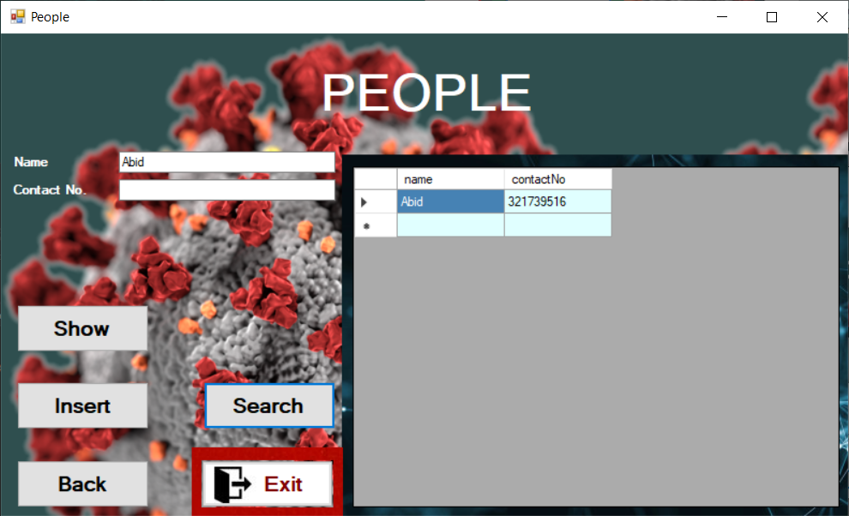

(i.e. Contact No.)

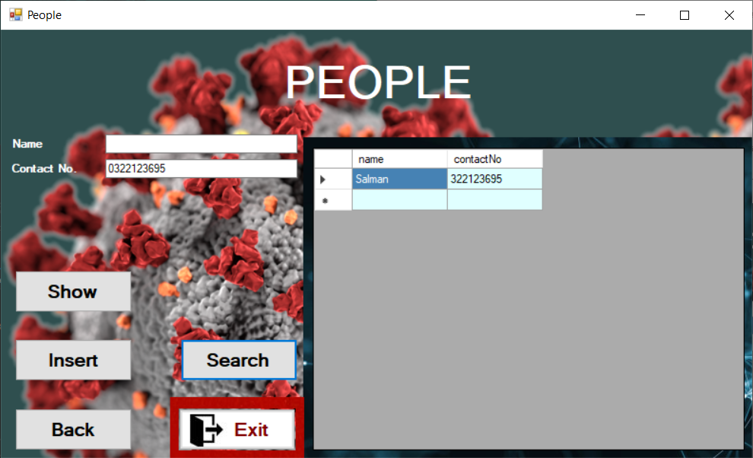

**New patient record** entered contained primary key validation check.

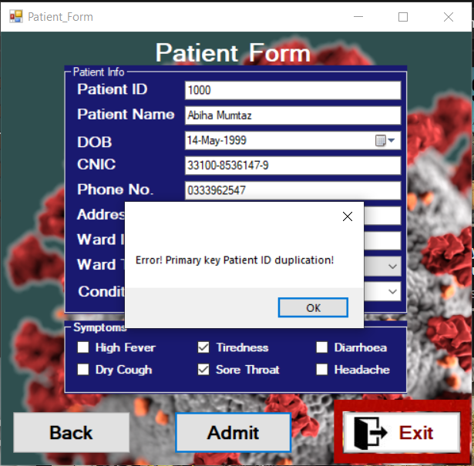

Correct Primary key.

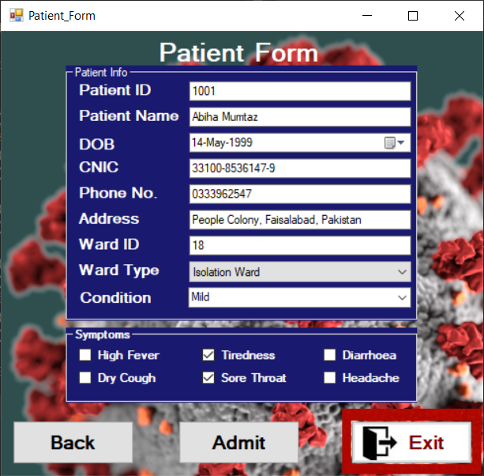

**Drop down menu** (Combo Box) for Condition selection.

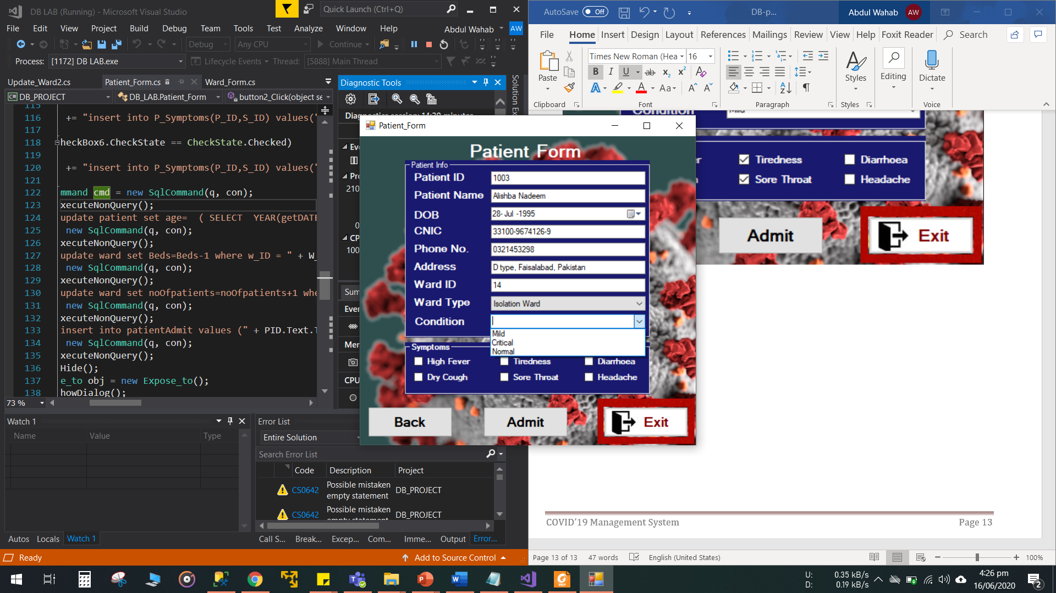

**Search patient**

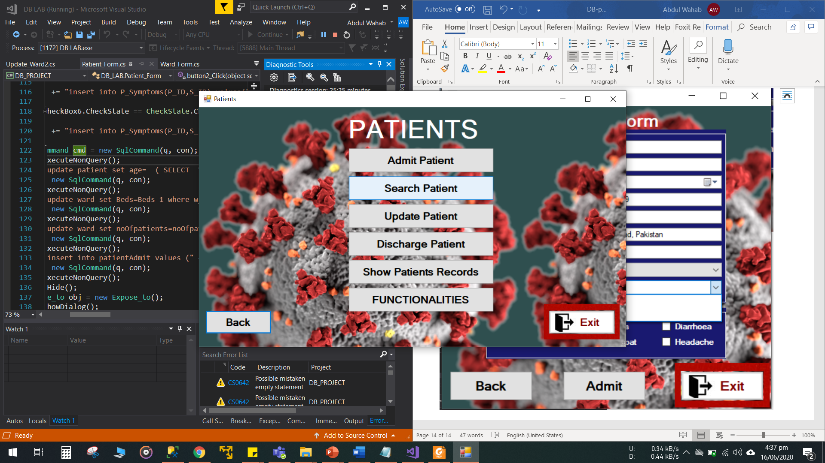

**Search on basis of any attribute using drop down menu.**

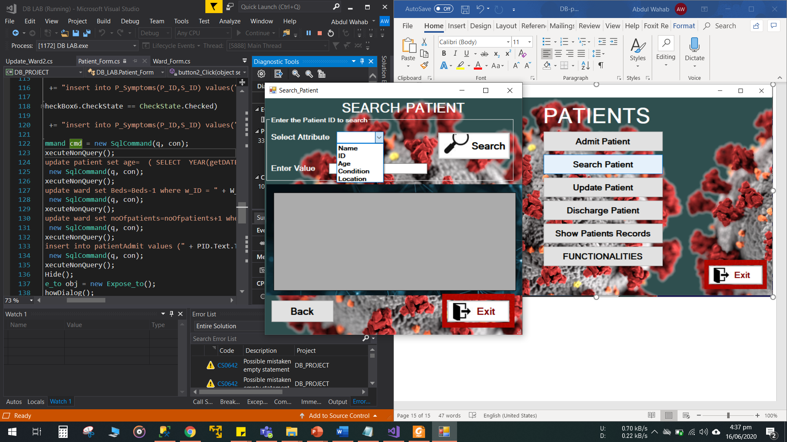

**Search result on basis of name.**

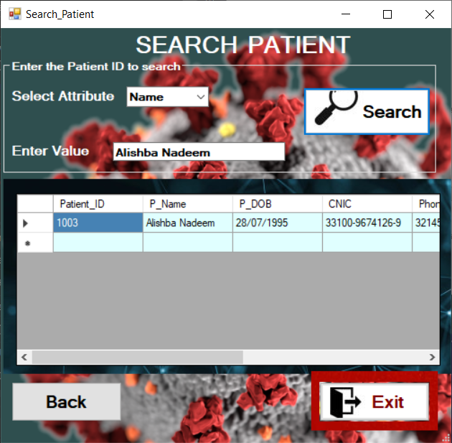

**Search result on basis of Patient ID.**

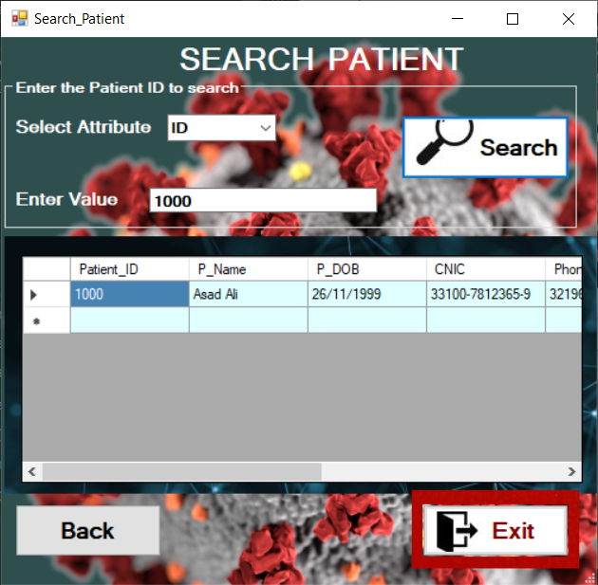

**Search result on basis of age.**

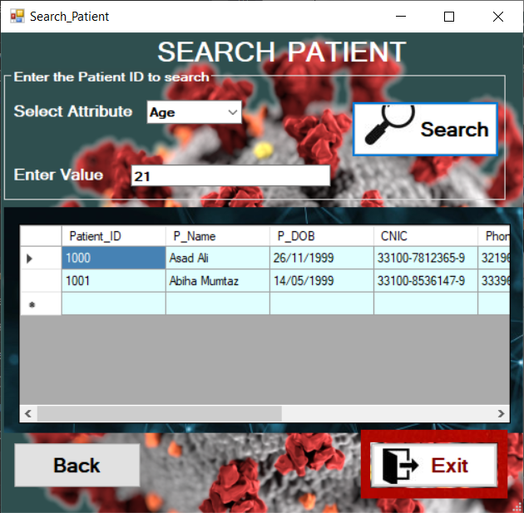

**Search result on basis of condition.**

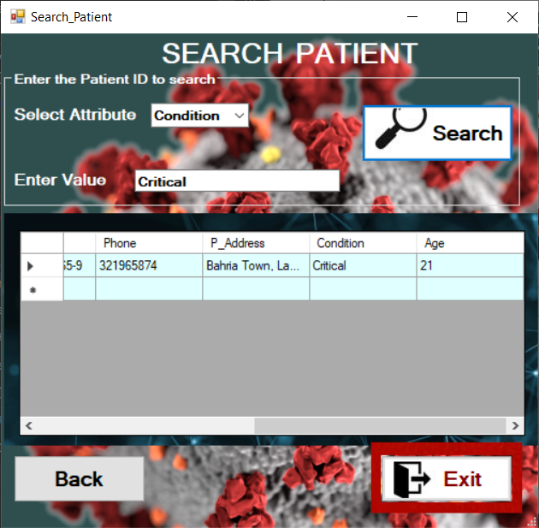

**Search result on basis of Location.**

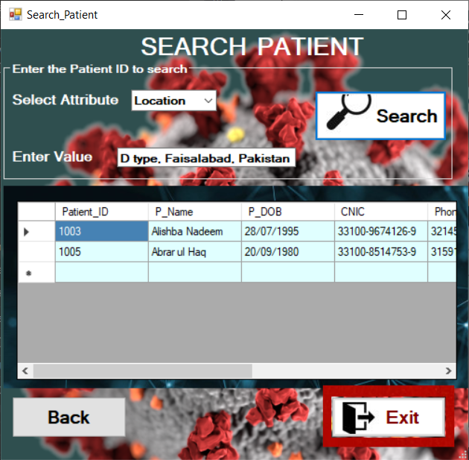

**Show patient record.**

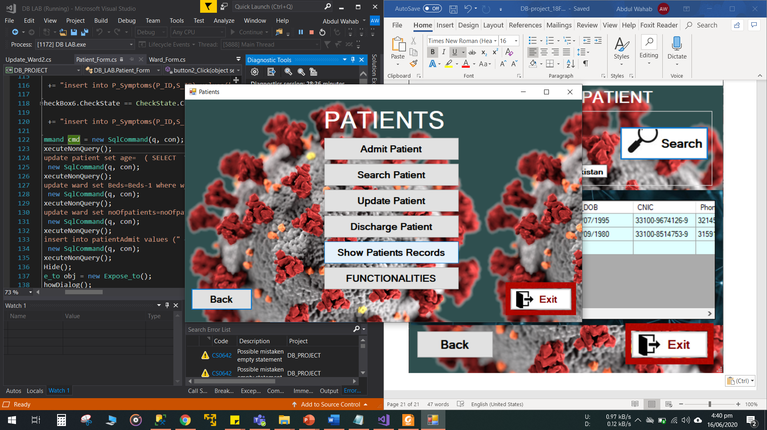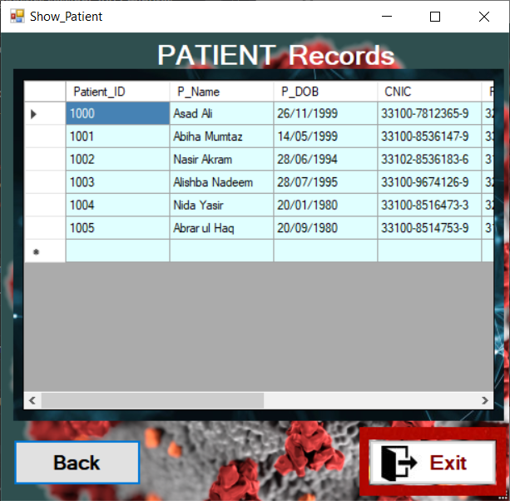

**More functionalities for patients. These functionalities search result can be used for decision making.**

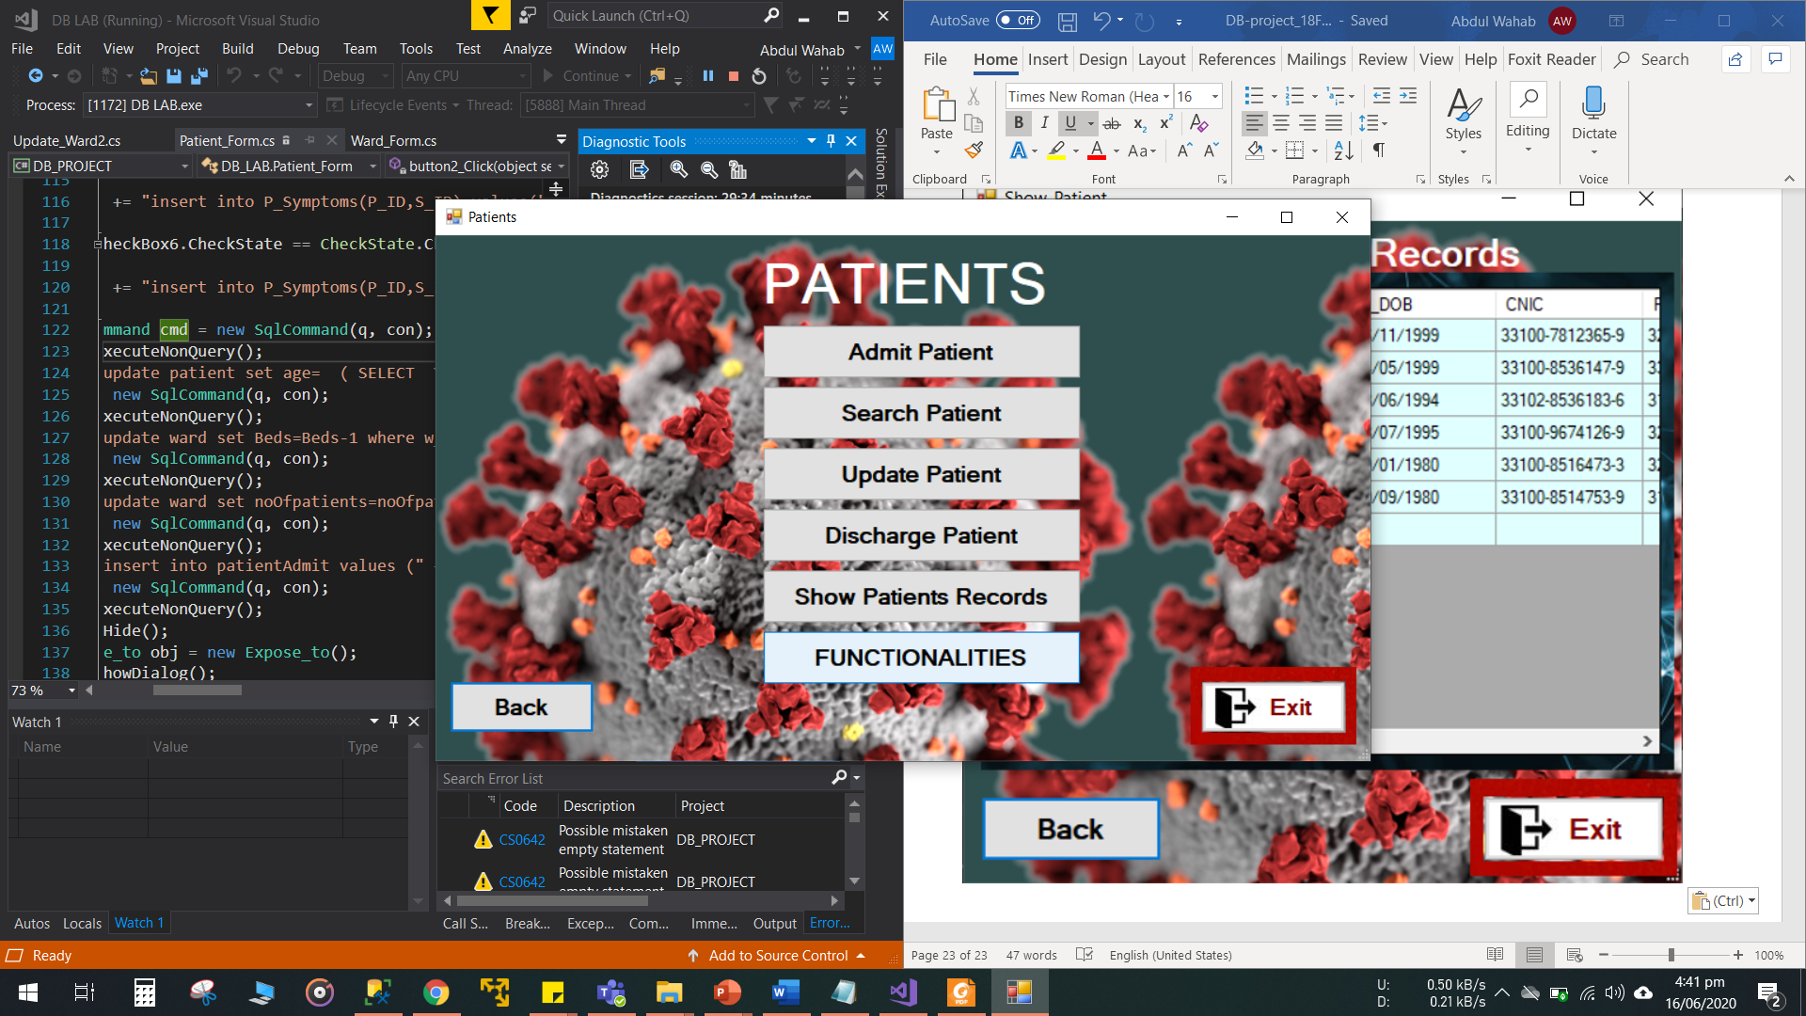

**Use of GROUP BY CLAUSE.**

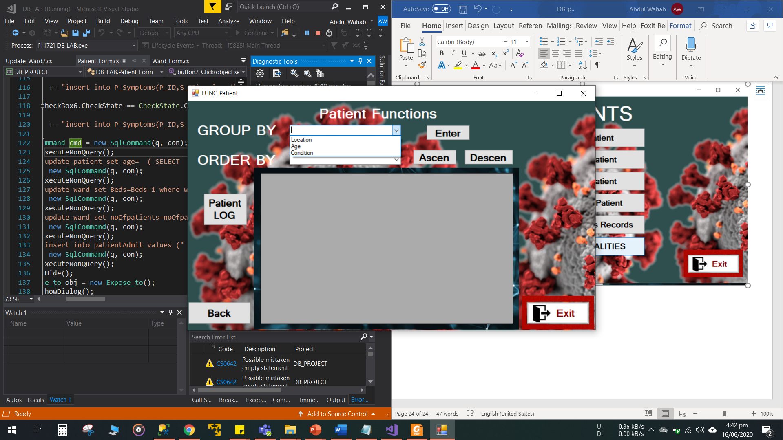

**GROUP BY Location.**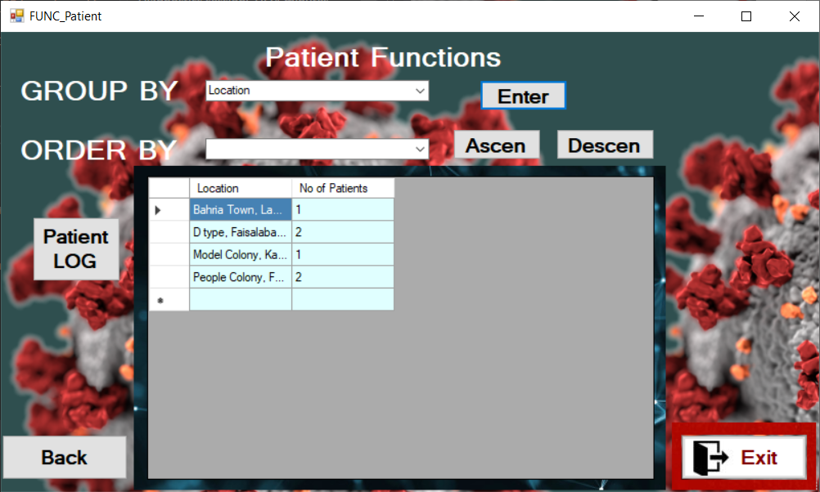

**GROUP BY Age.**

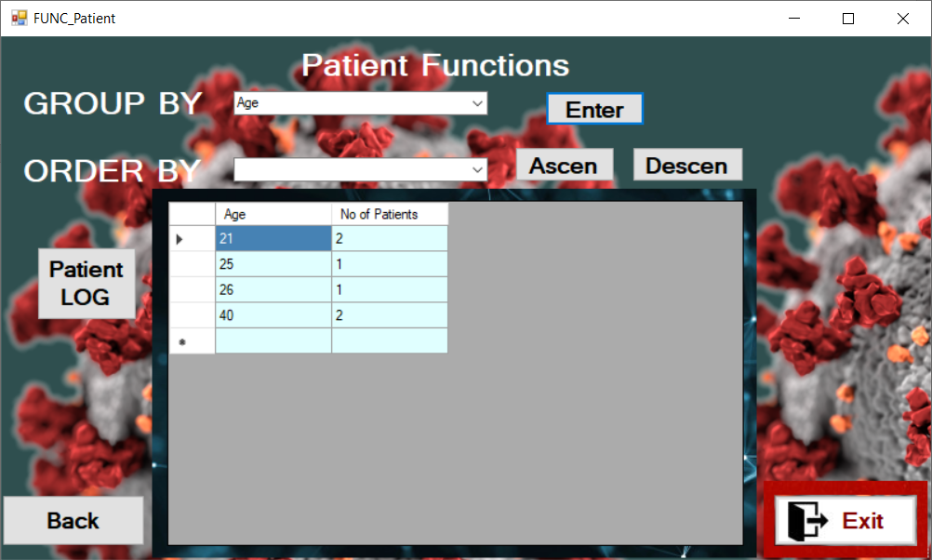

**GROUP BY Condition.**

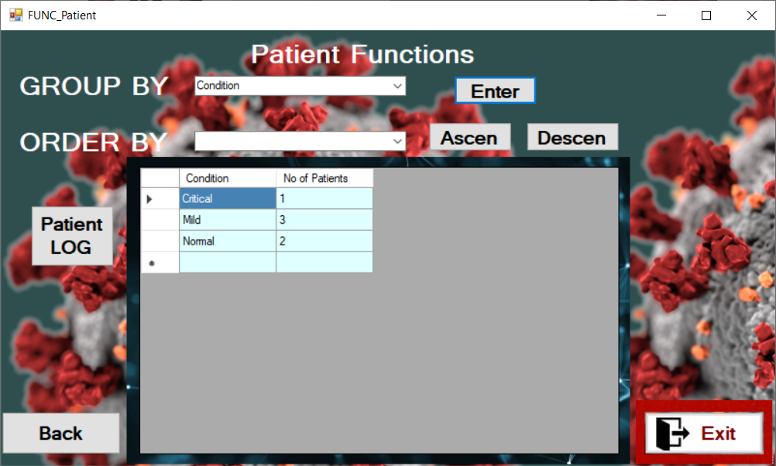

**Use of ORDER BY CLAUSE.**

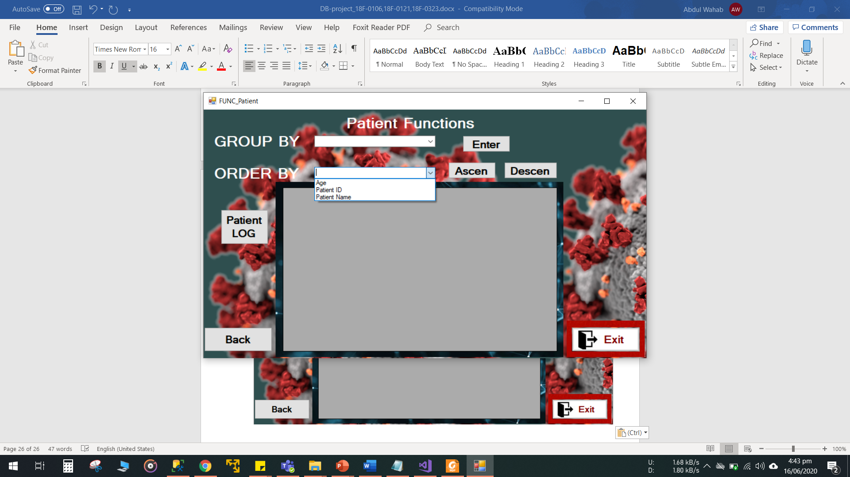

**ORDER BY Age.**

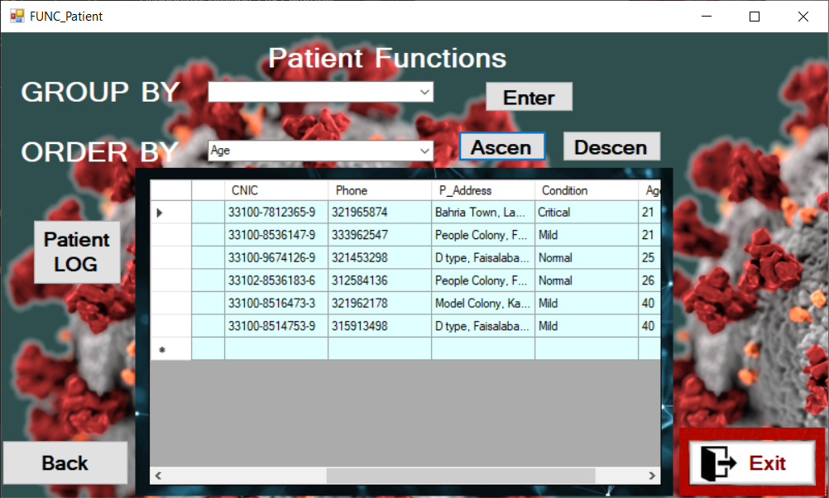

**ORDER BY Patient ID.**

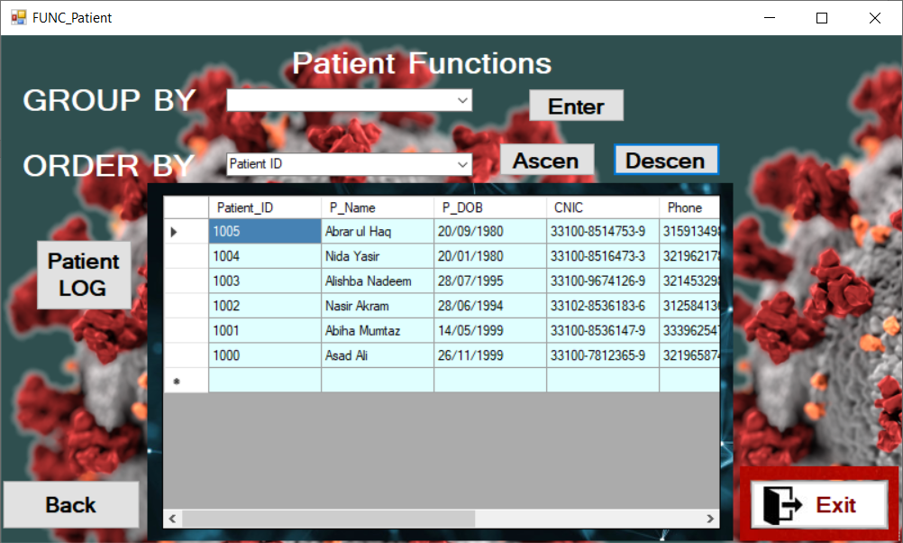

**ORDER BY Patient Name.**

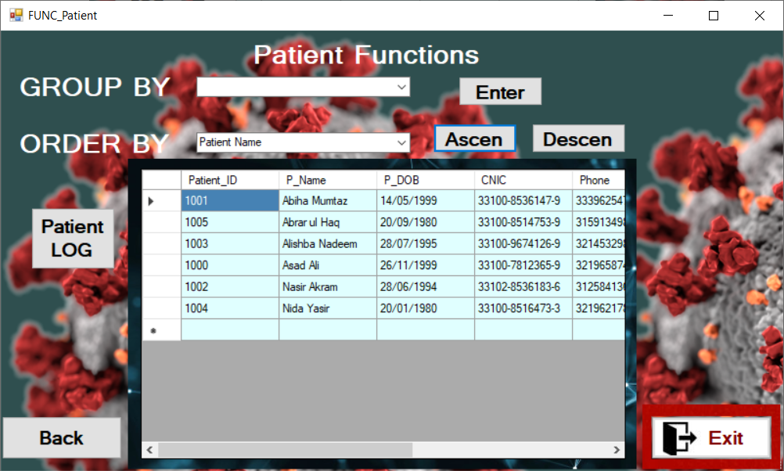

**All the patient data is recorded in log form that contains date admit, date discharge attributes etc.**

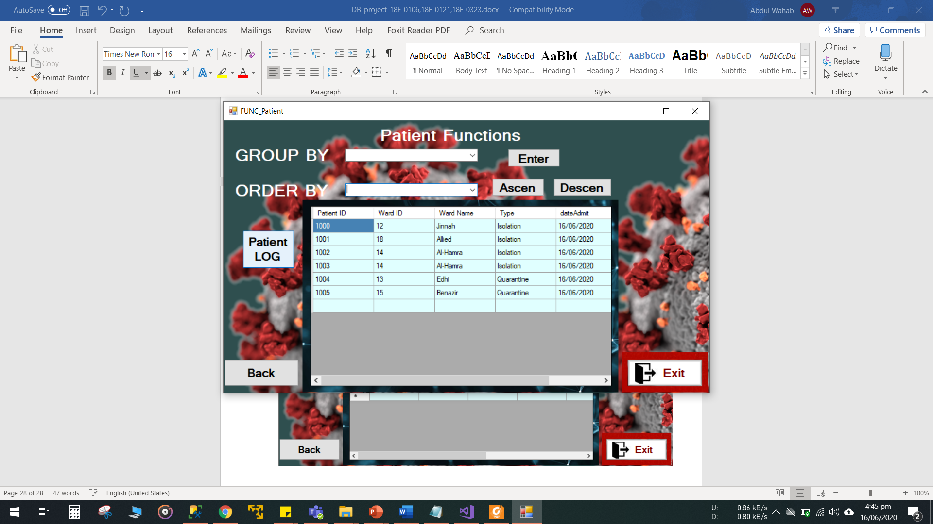

**Update Patient (Any attribute can be updated).**

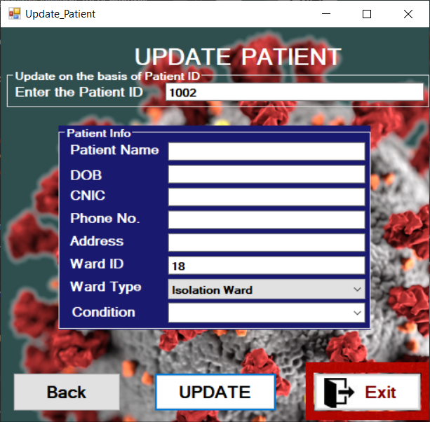

**Discharge Patient**

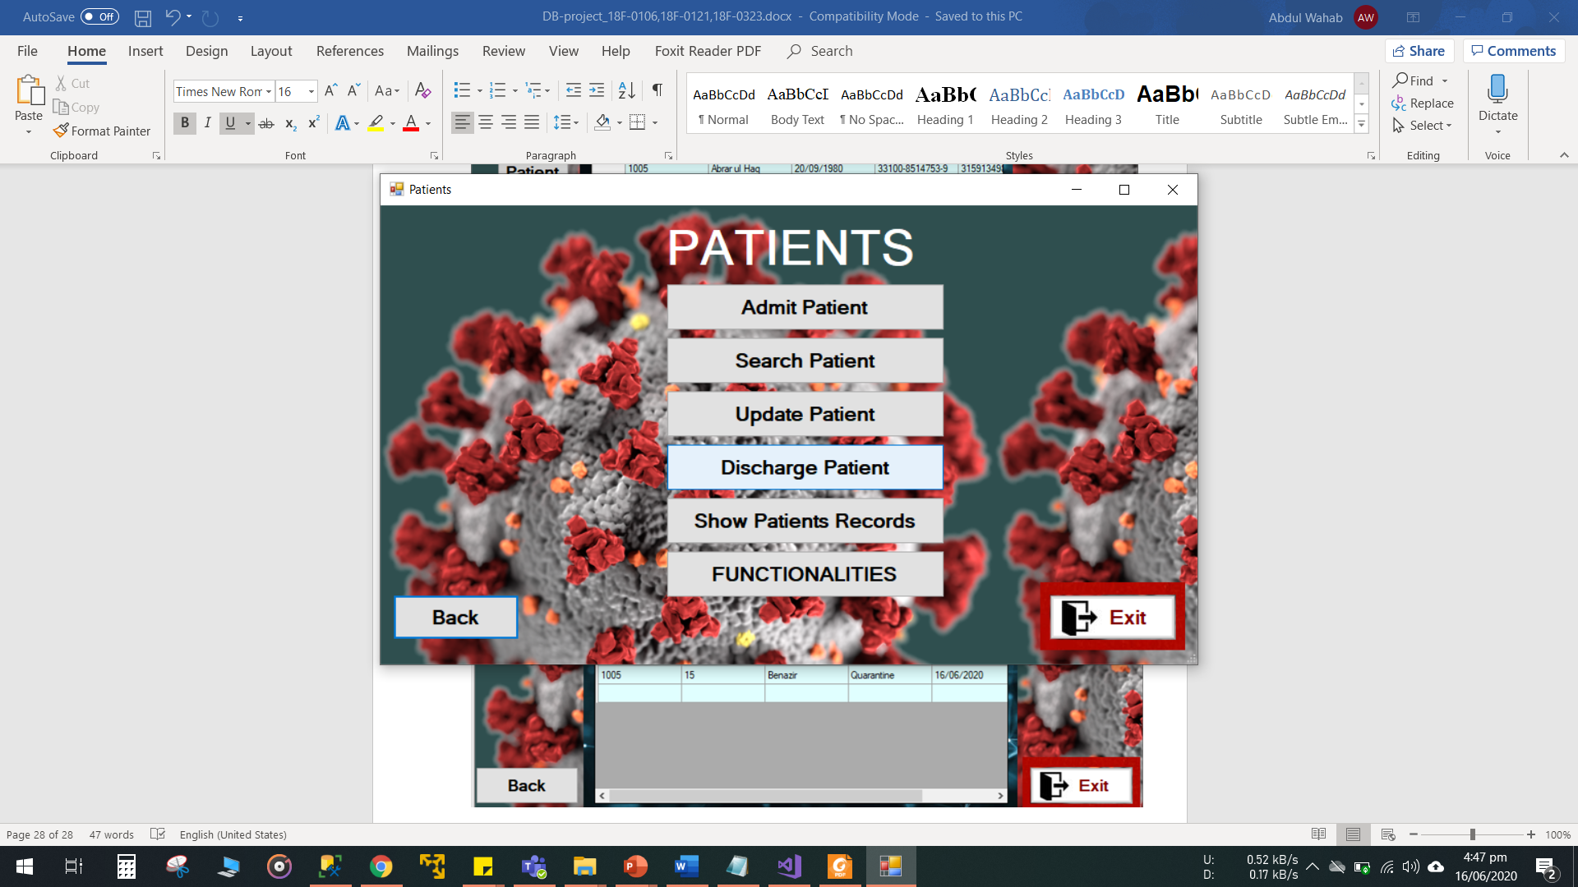

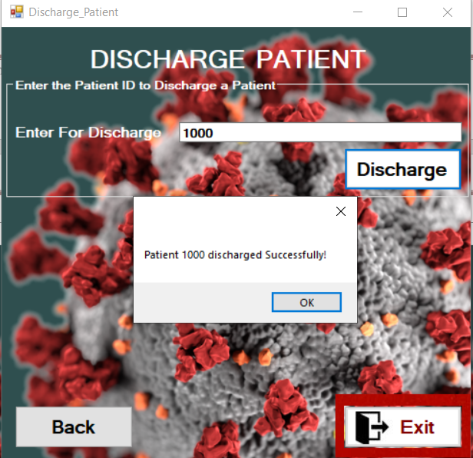

**Date of discharge is updated in “*Patient log”.***

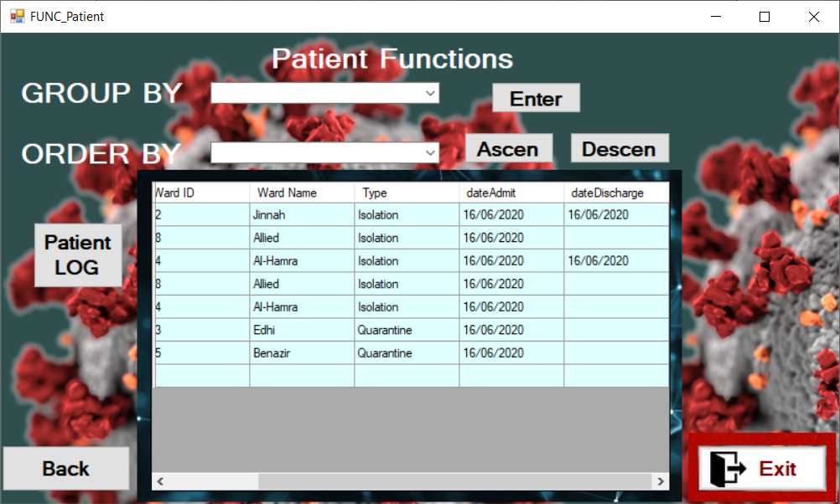

**Patient LOG**

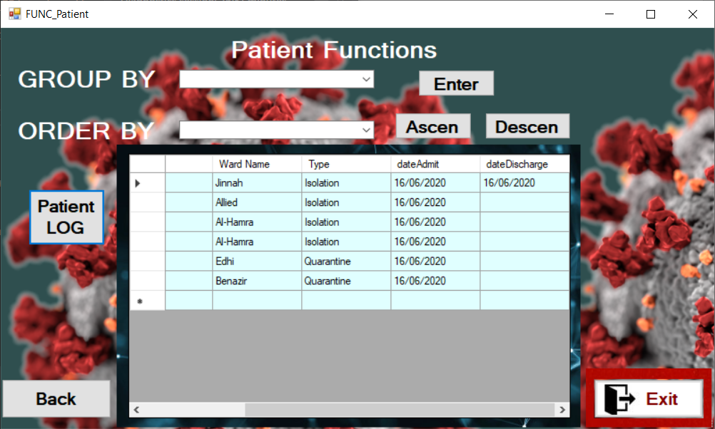

**Wards Entity:**

**On clicking *“Ward”* in the main form.**

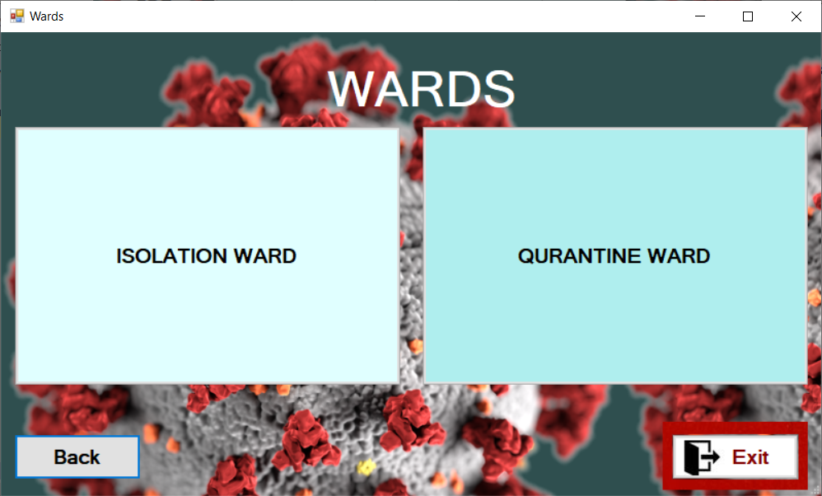

**Isolation Ward management.**

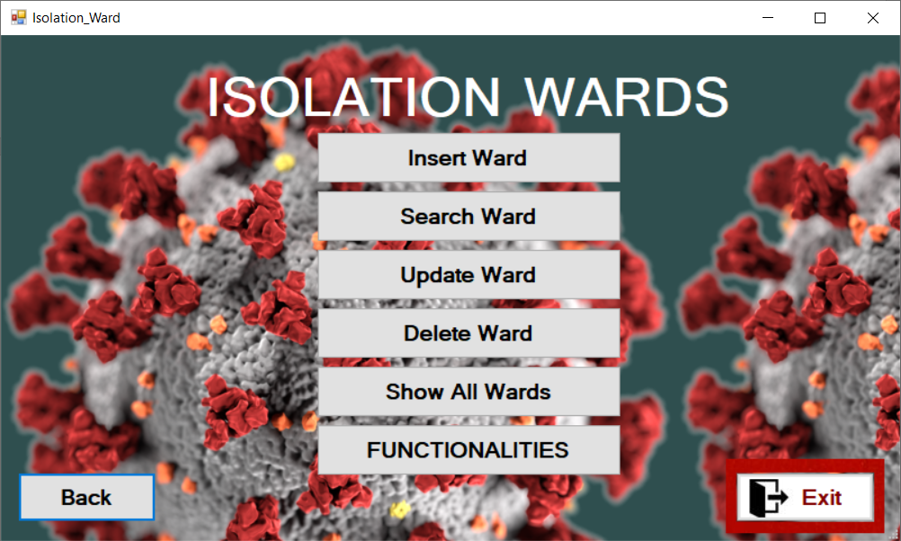

**Isolation ward insertion form with drop down menu for sector selection.**

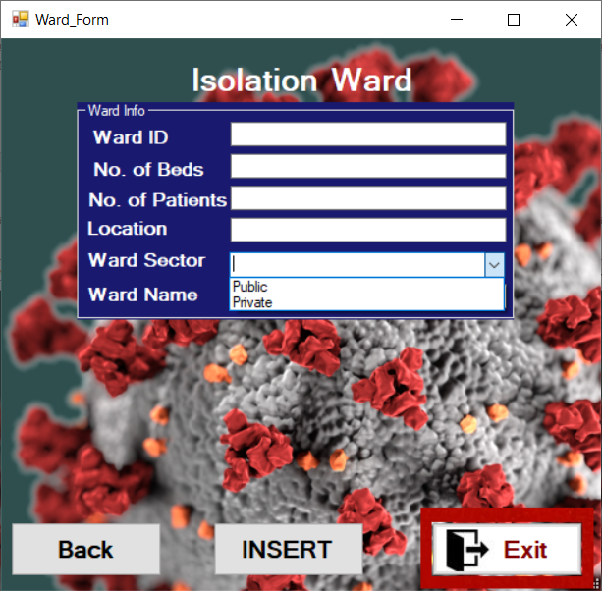

**Search on the basis of any attribute.**

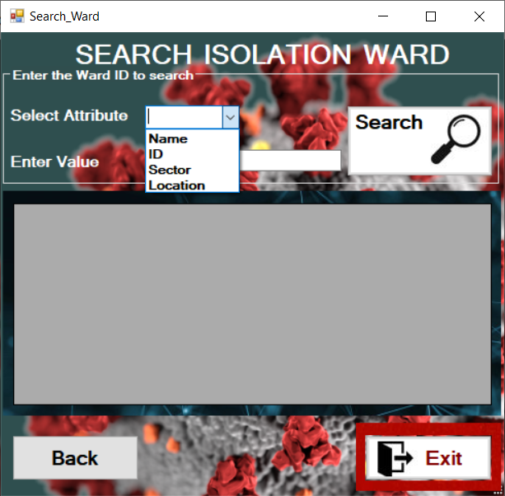

**On basis of sector.**

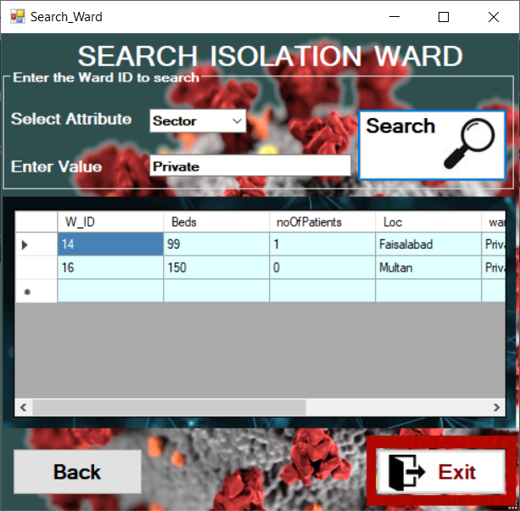

**Show all isolation wards.**

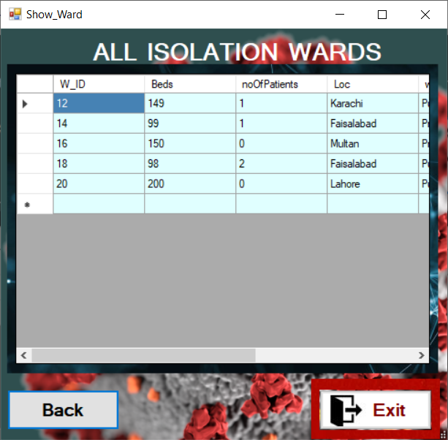

**Isolation ward functionalities. Group BY and Order BY.**

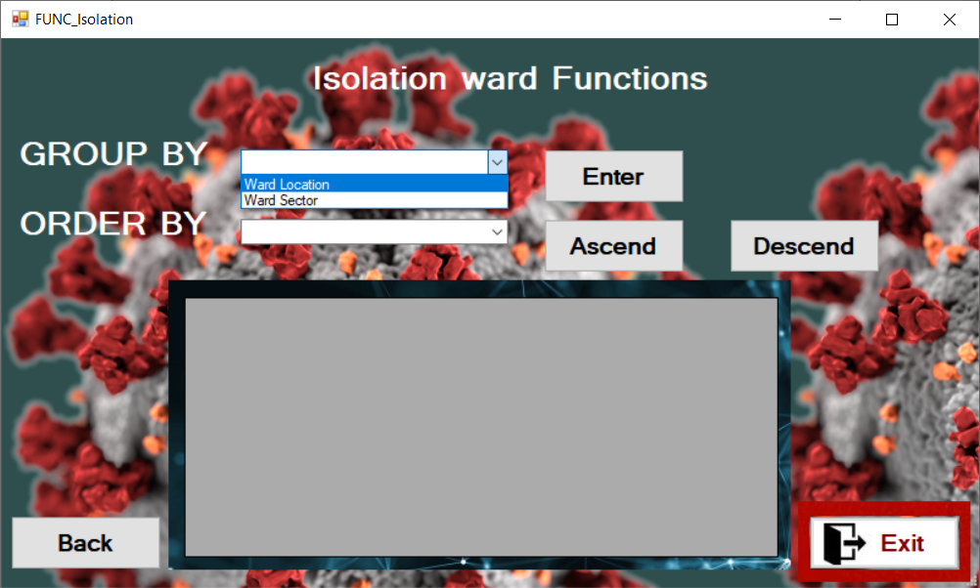**Group BY ward Location**

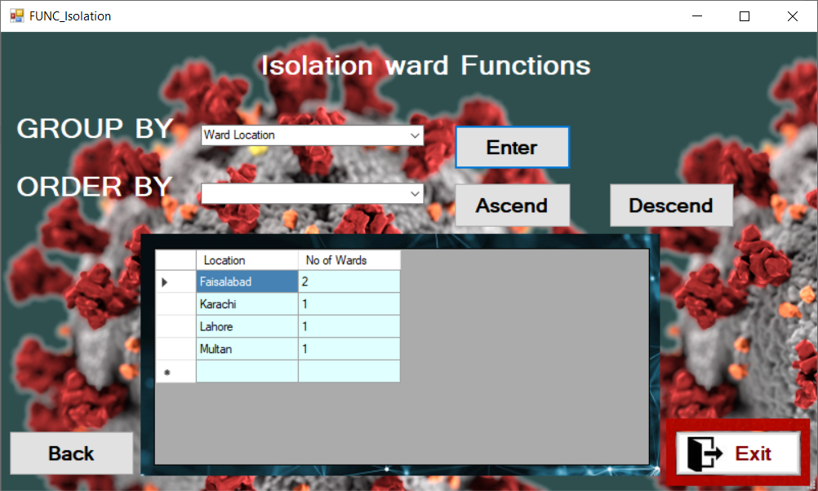

**Group BY ward Section**

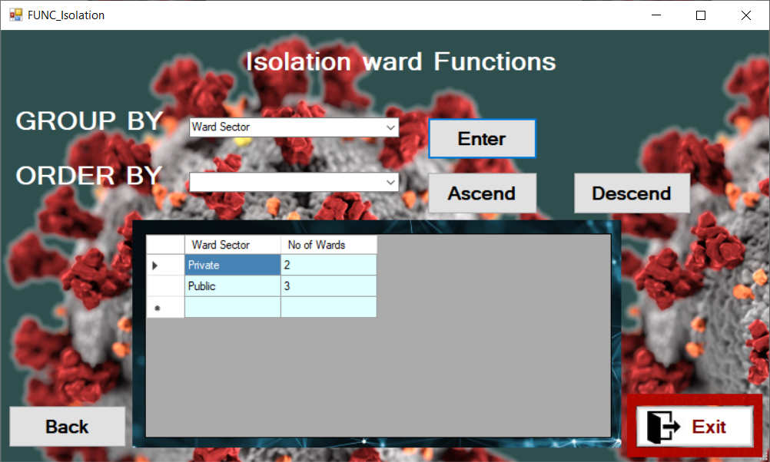

**Order BY No. of Beds**

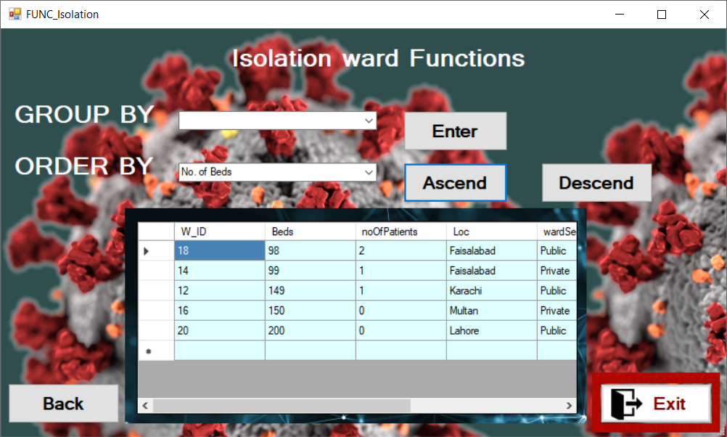

**Order BY No. of patients (Ascend)**

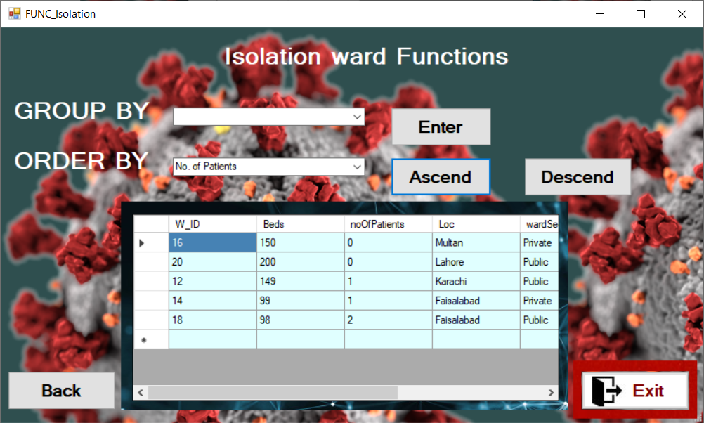

**Order BY No. of patients (Descend)**

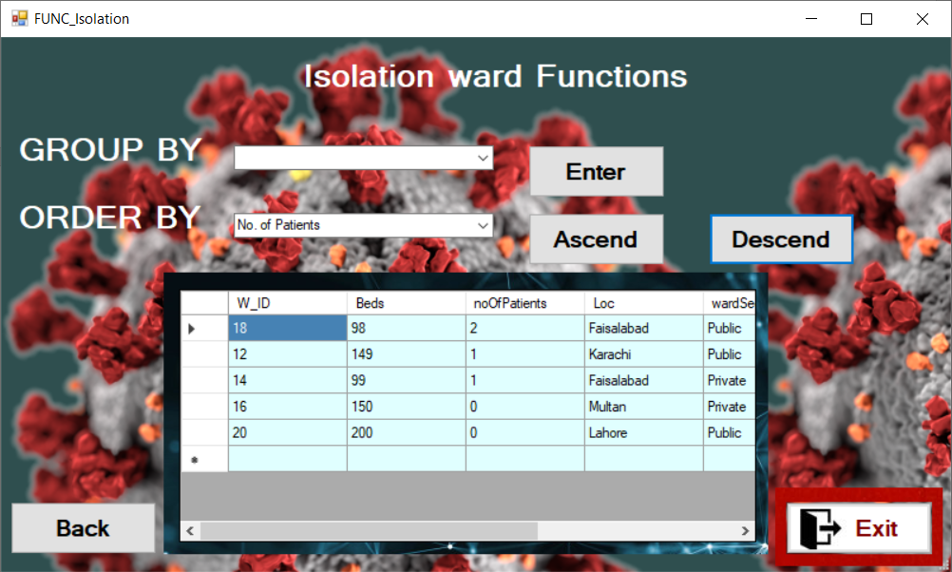

**Update isolation ward.**

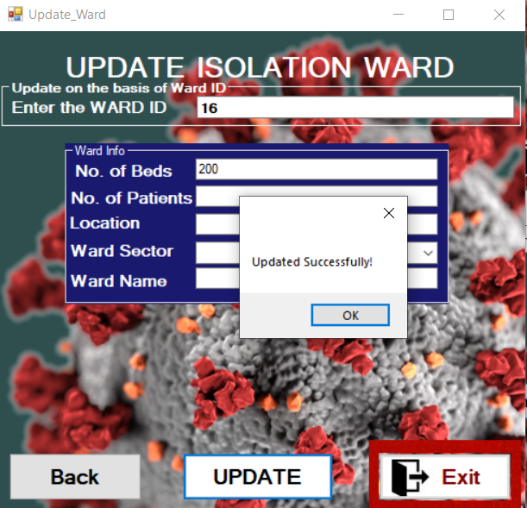

**Dismantle isolation ward.**

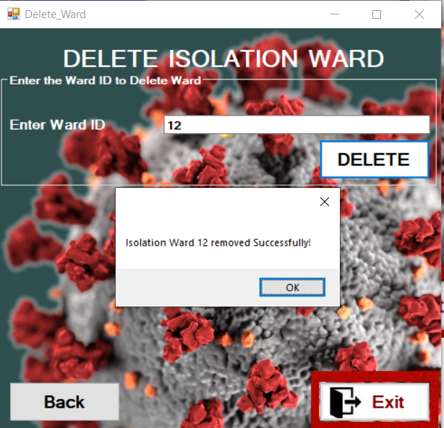

**On deleting the Ward all the Patient in that ward are shifted to *“Default ward”.***

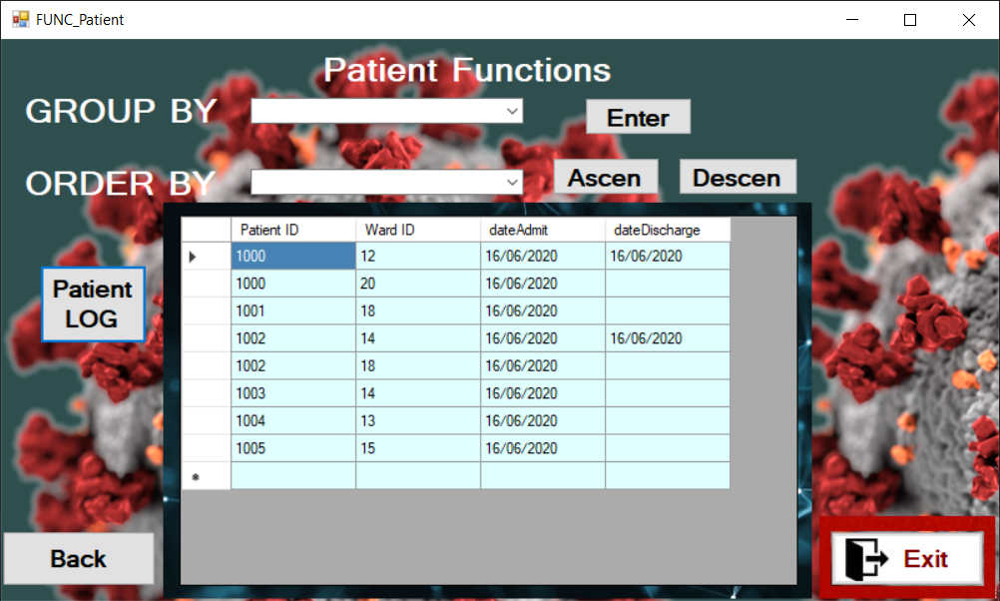

**Quarantine Ward management.**

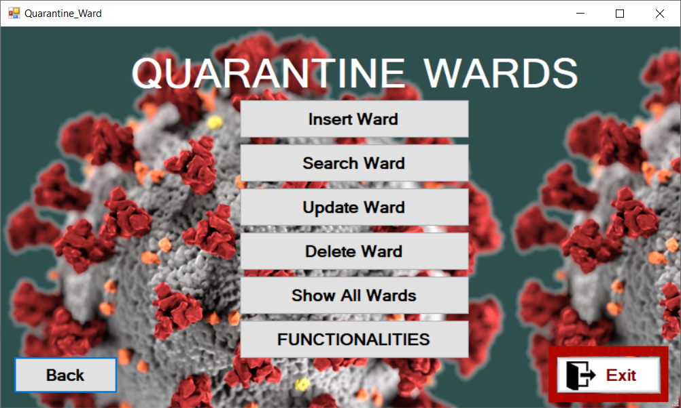

**Show all Quarantine Wards.**

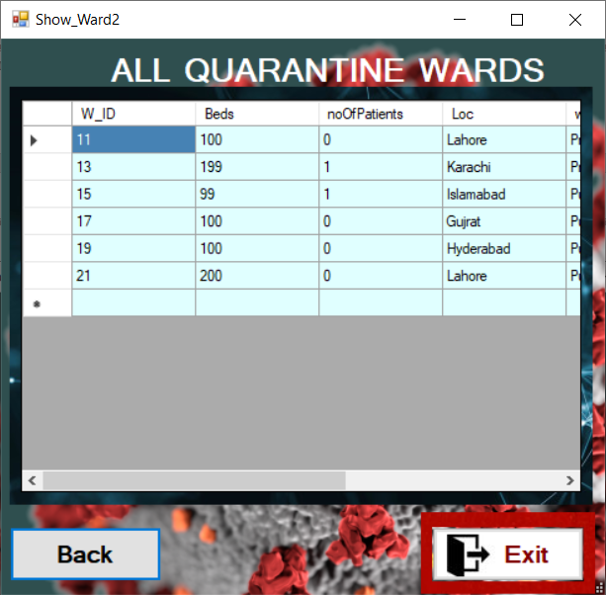

**More Quarantine Ward Functions.**

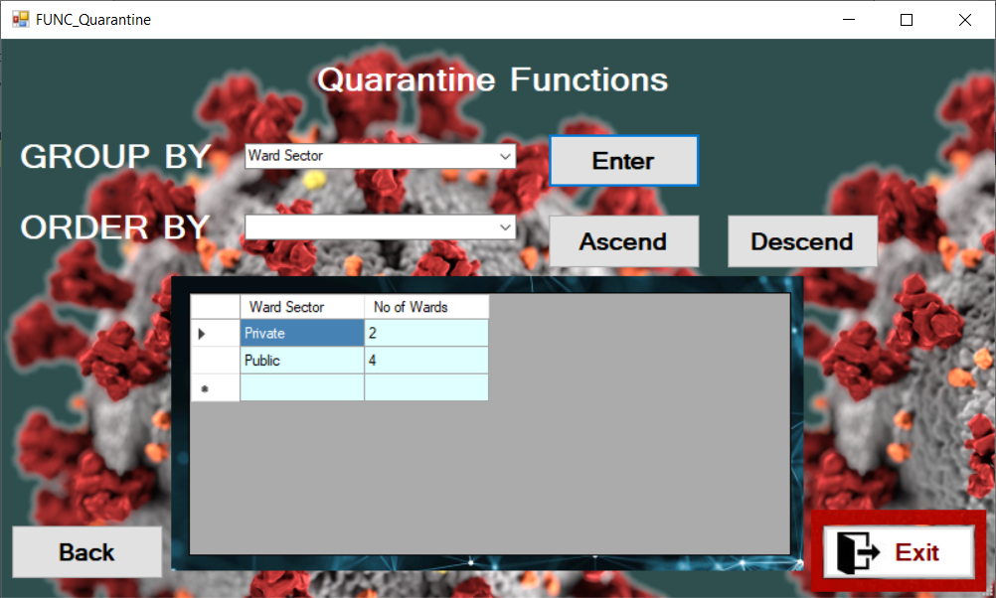

**GROUP BY Quarantine Ward Location.**

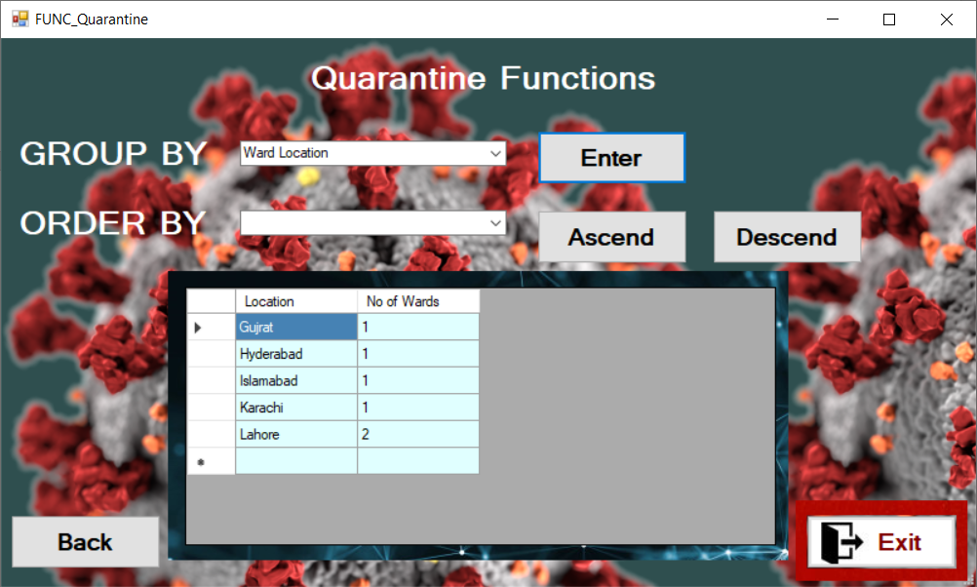

**ORDER BY Quarantine Ward ID (ASCEND).**

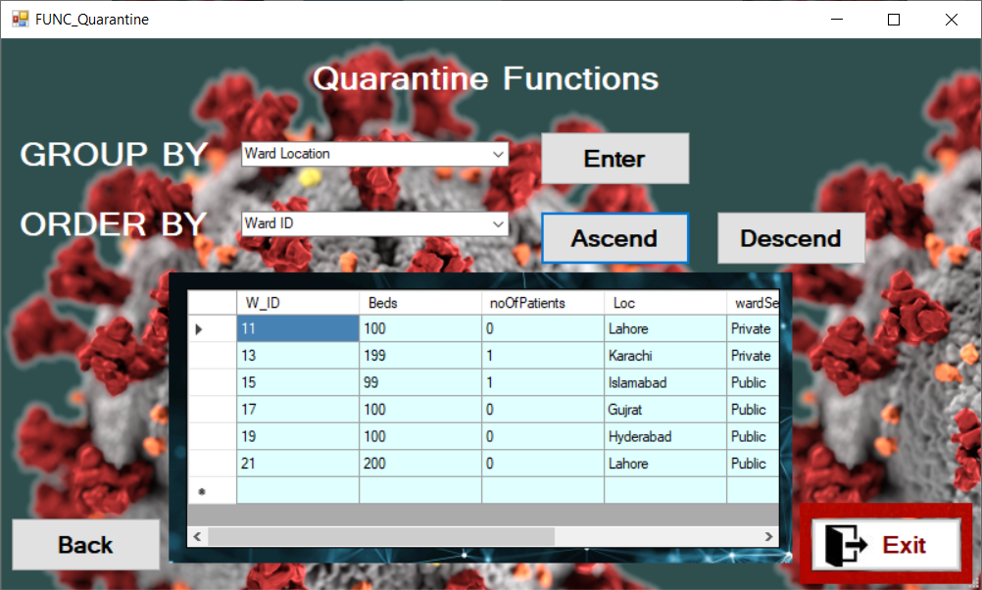

**Quarantine Ward ID Insertion Form.**

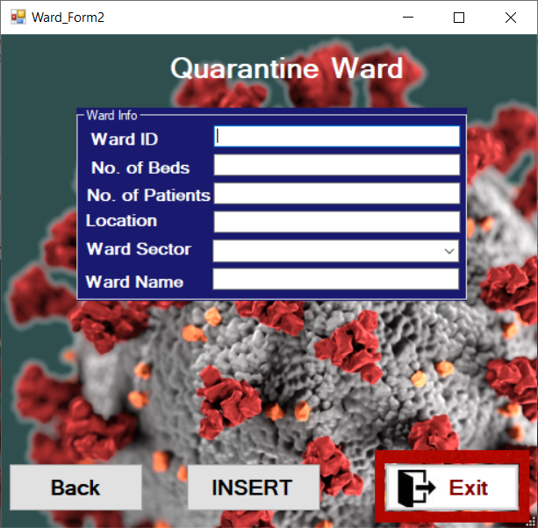

**Symptoms:**

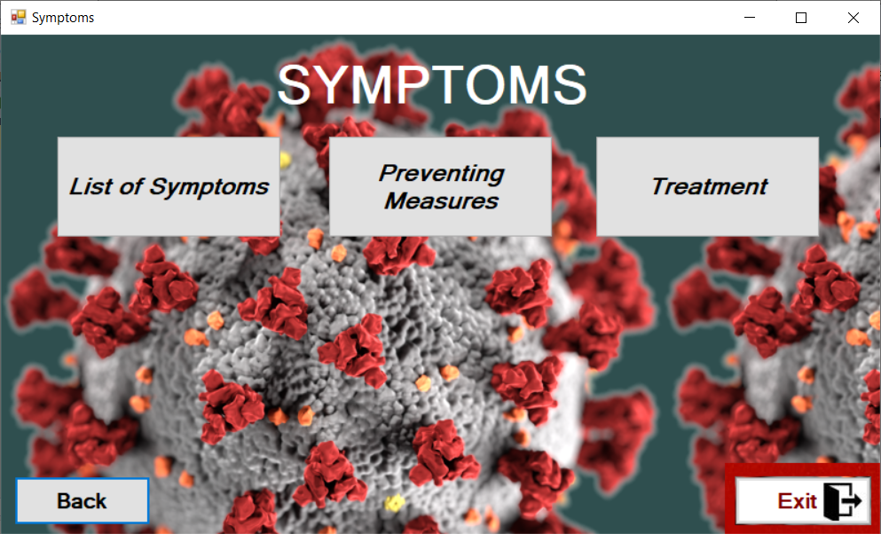

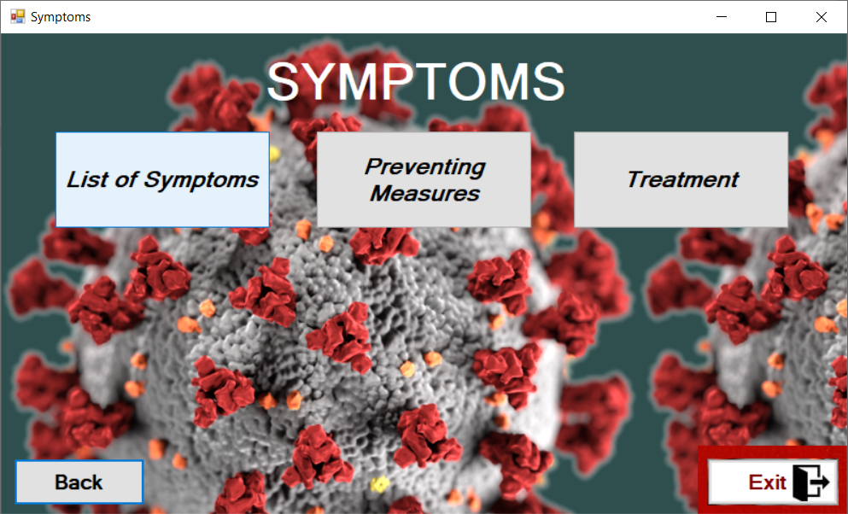

**List of symptoms (Static Data)**

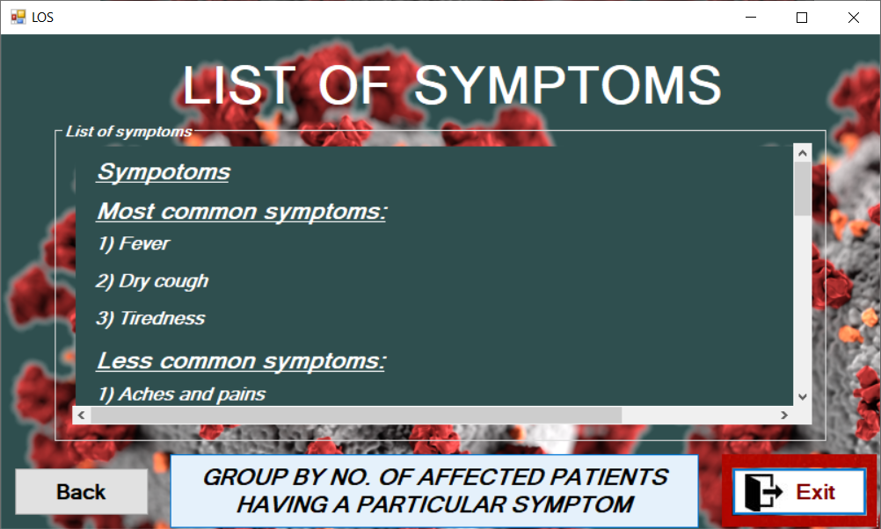

**Showing Symptoms in terms of vastness.**

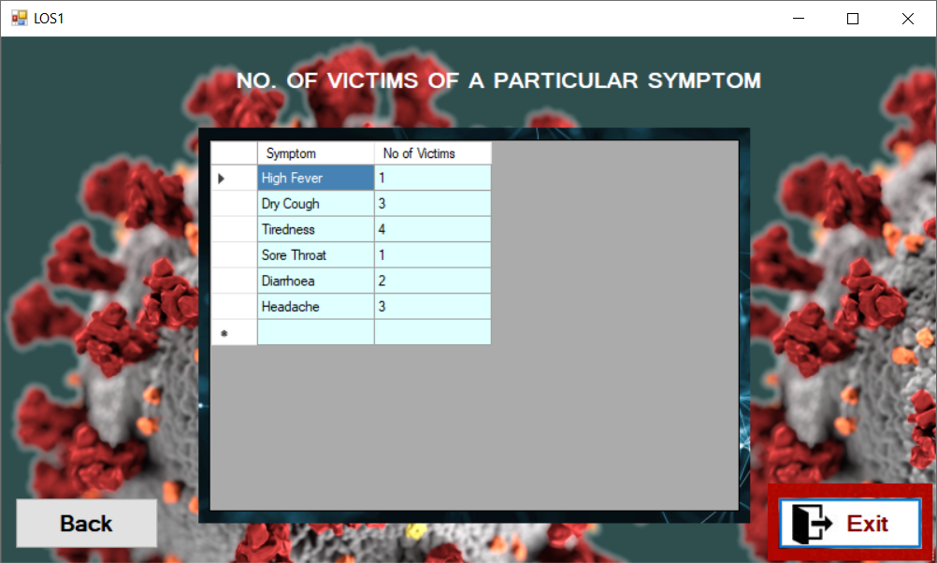

**Preventing measures.**

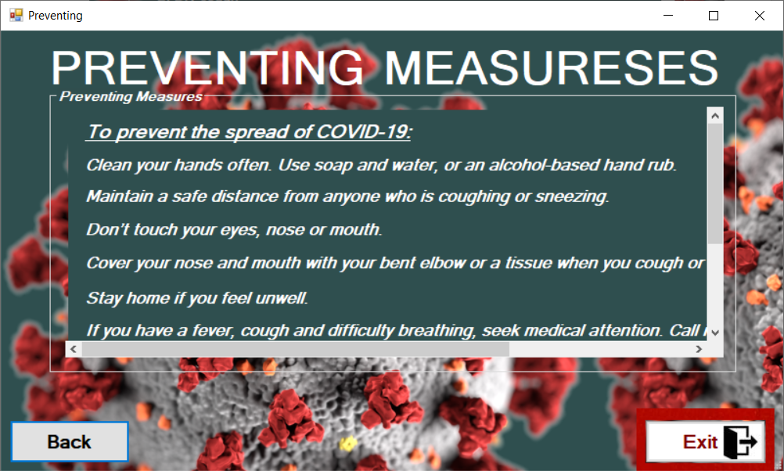

**Treatment option.**

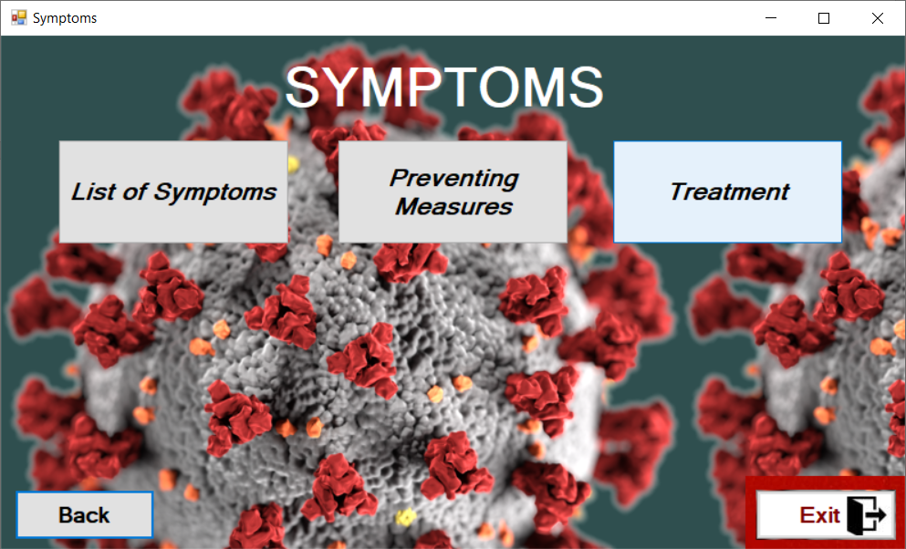

**Treatment**

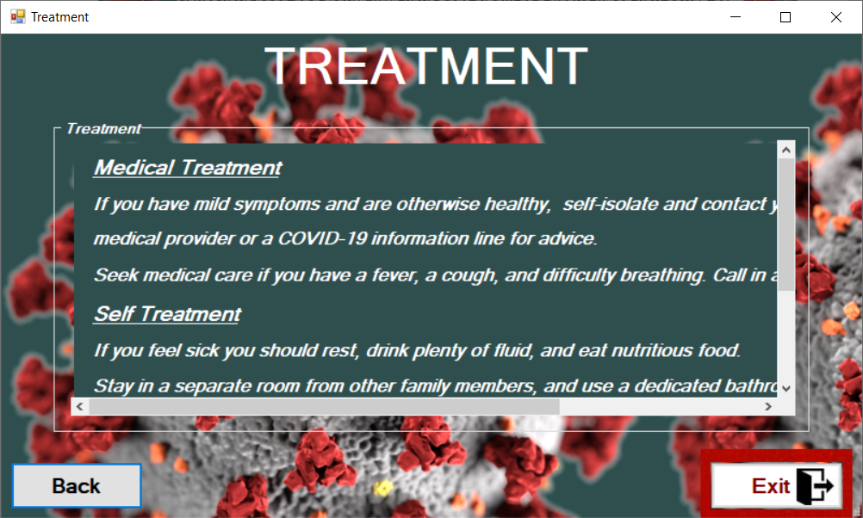

**Information Desk:**

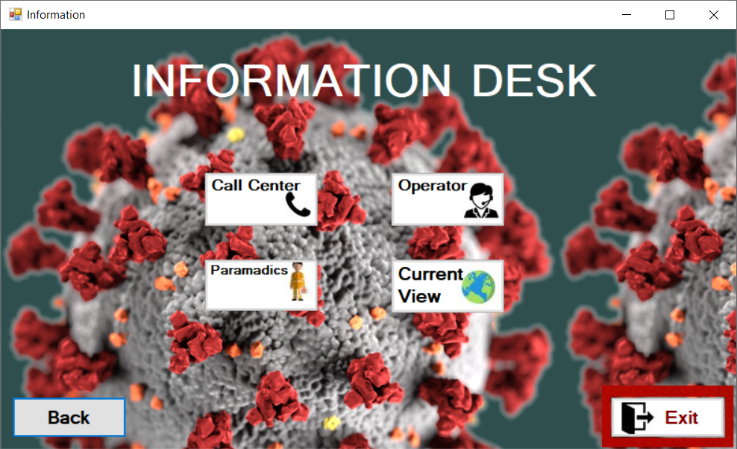

**Emergency Call Center:**

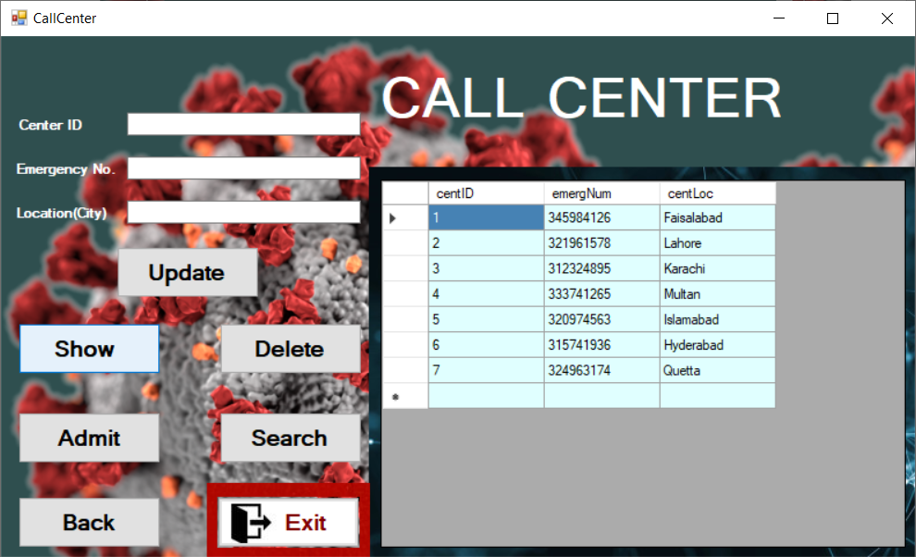

**Primary Key validation.**

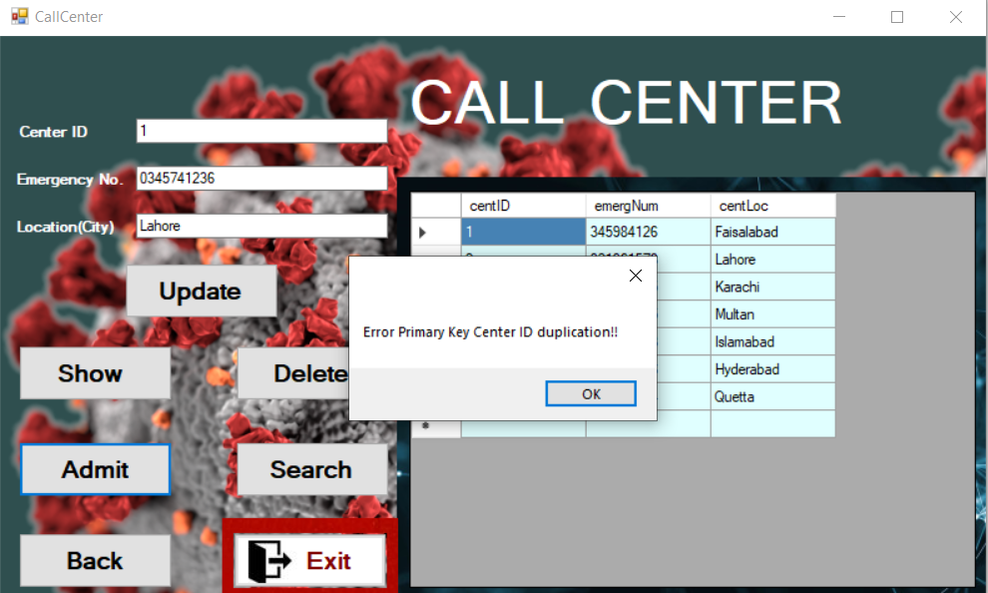

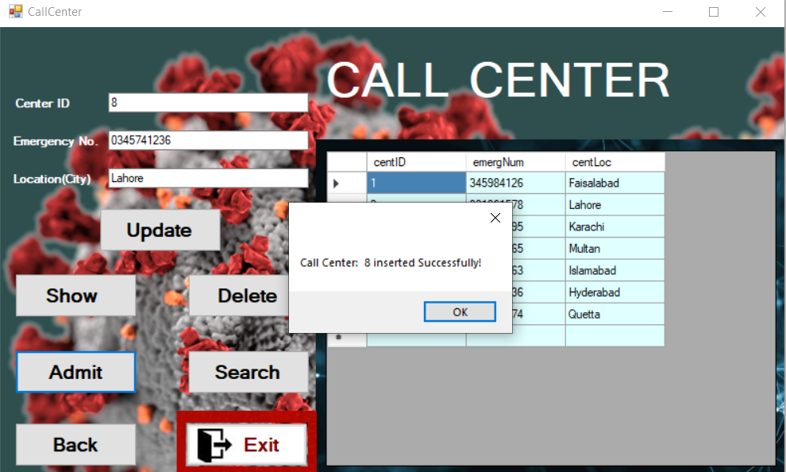

**Show Call Center Data.**

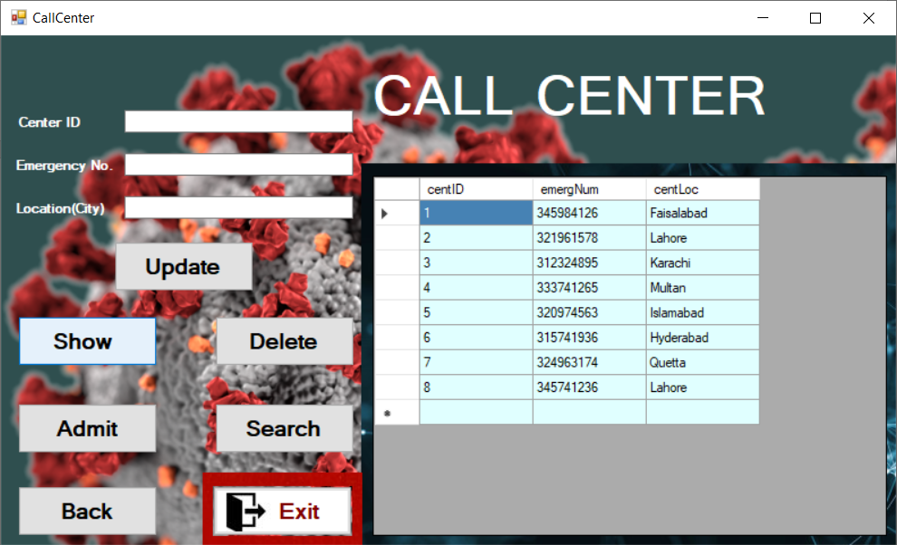

**Search in Call Center on basis of any attribute.**

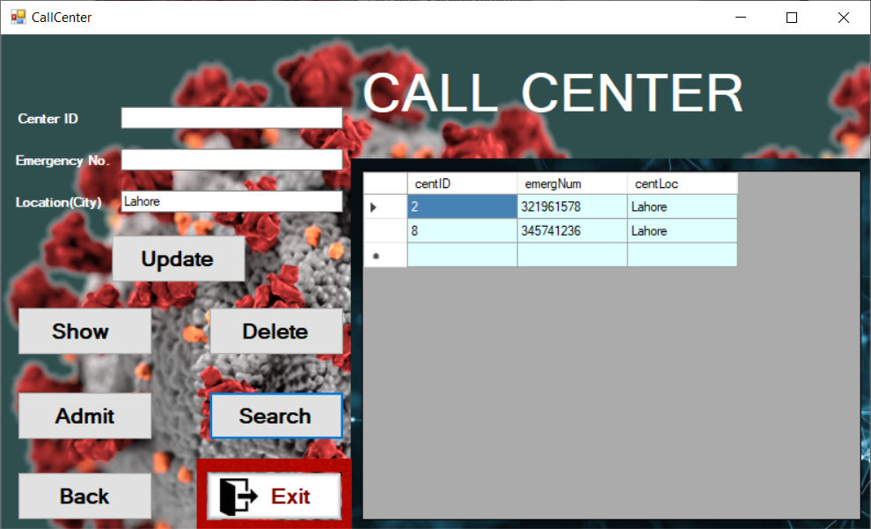

**Deletion in Call Center.**

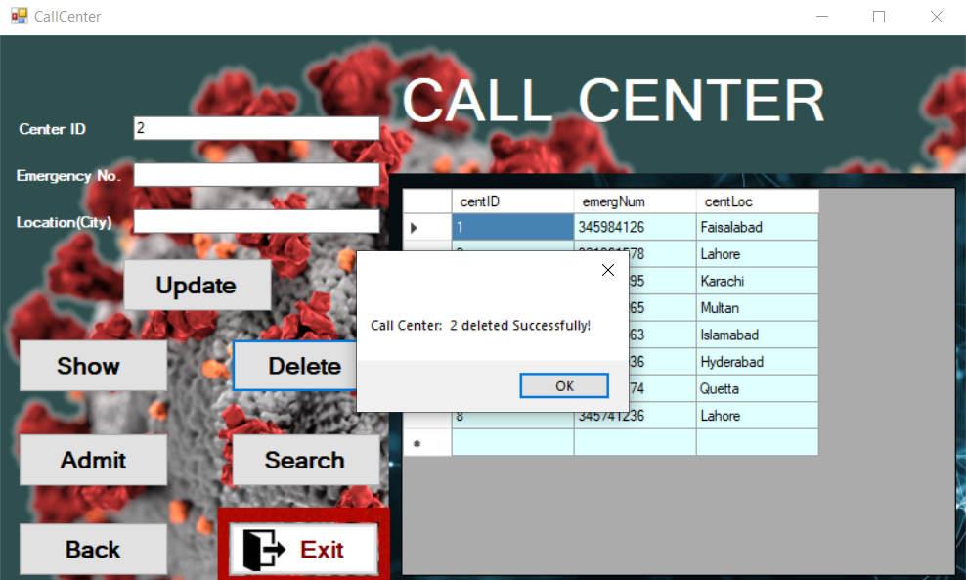

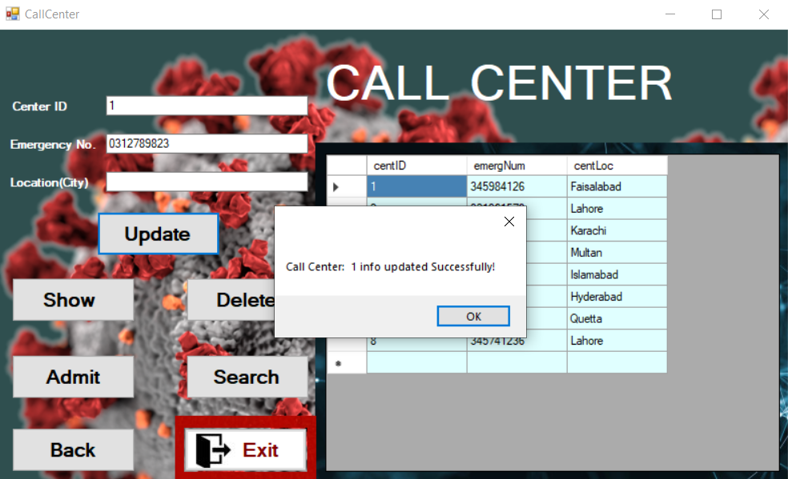

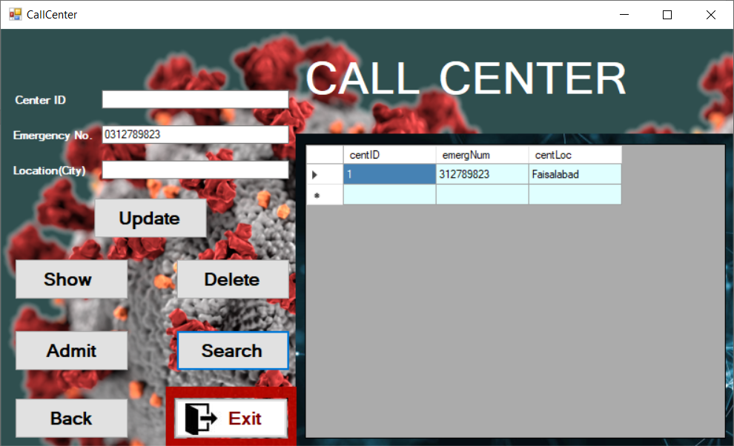

**Information Desk Panel.**

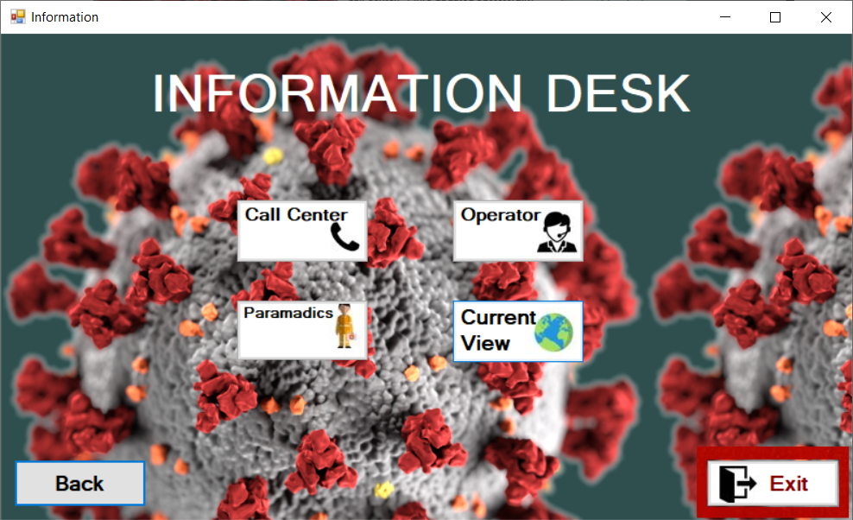

**Map view**

**Shows Geo map data.**

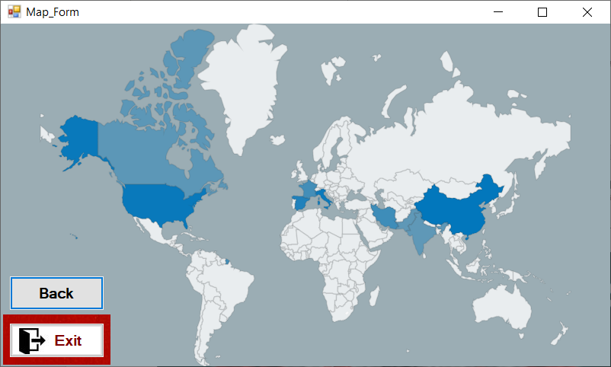

**Operator**

**Show Operator data.**

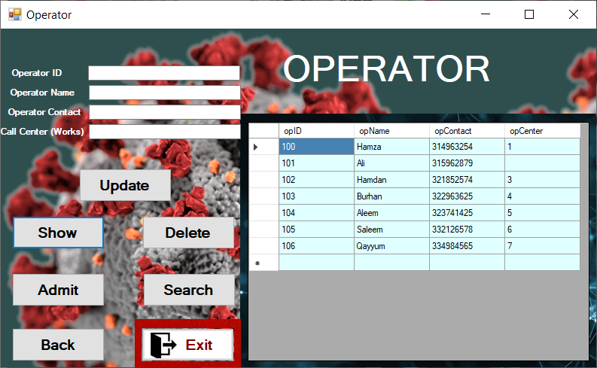

**Search on the basis of Operator name attribute.**

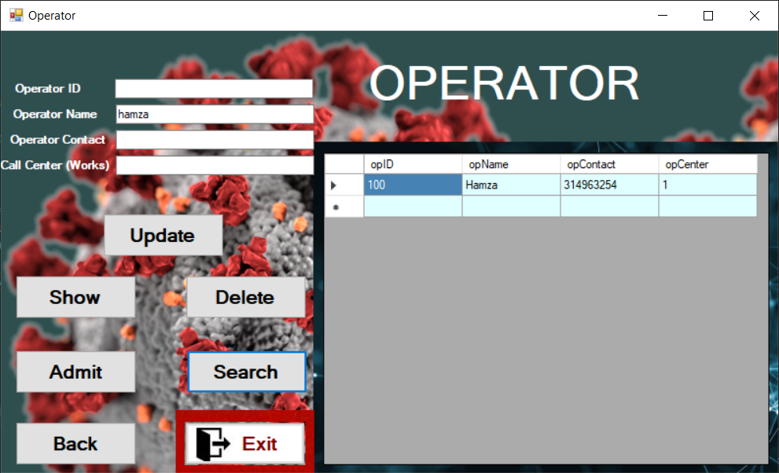

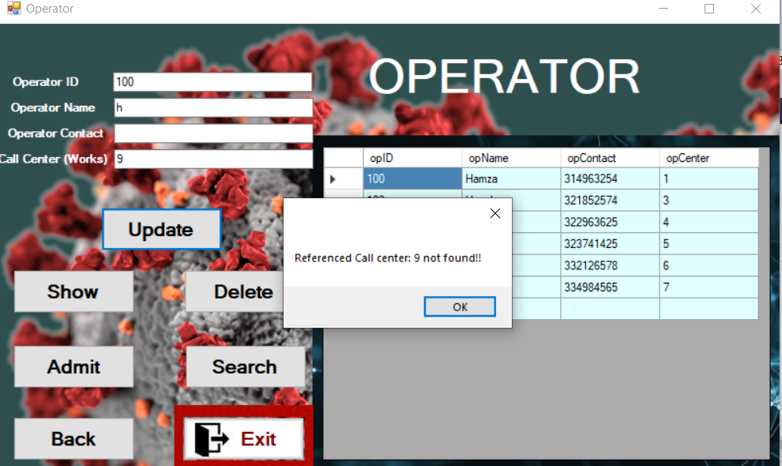

**Primary key constraint as primary key is *mandatory*.**

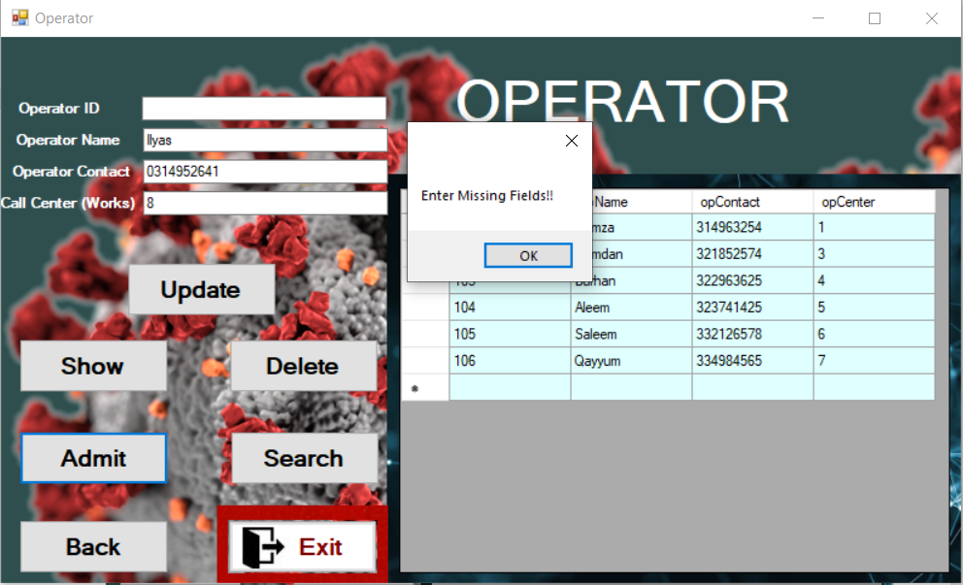

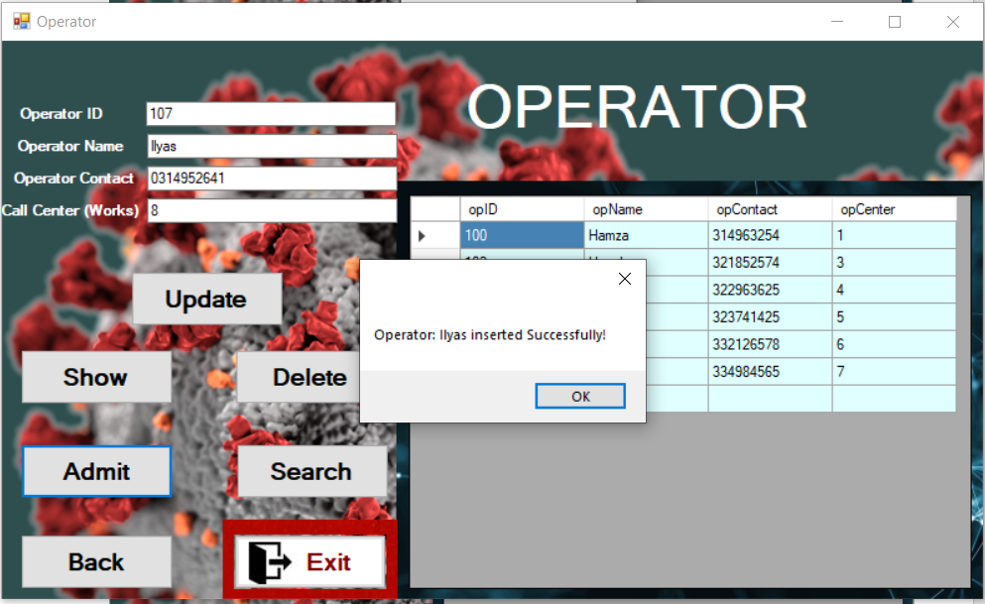

**Paramedics**

**Show Paramedics data.**

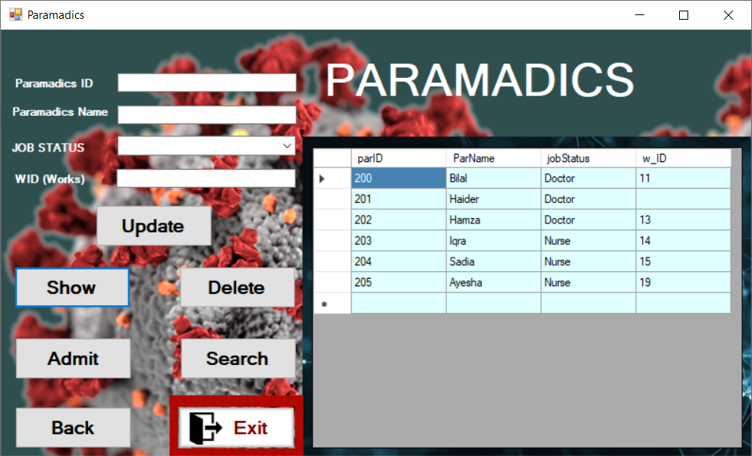

**Search on basis of Paramedics ID.**

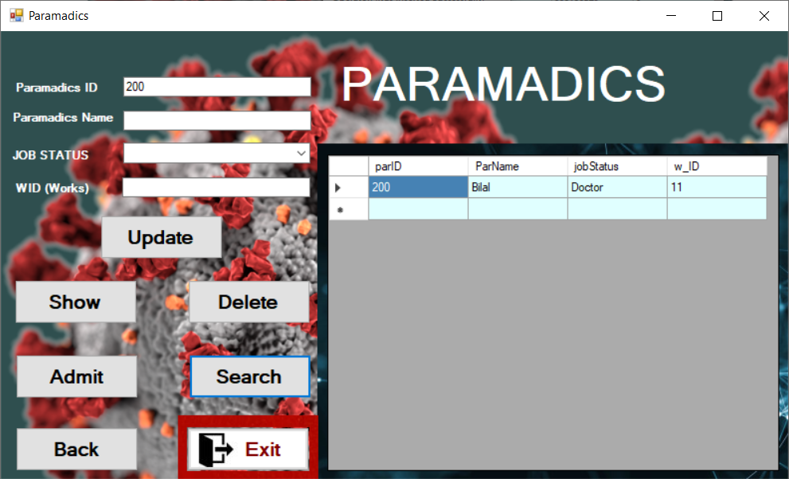

**JOB STATUS Selection using drop down menu.**

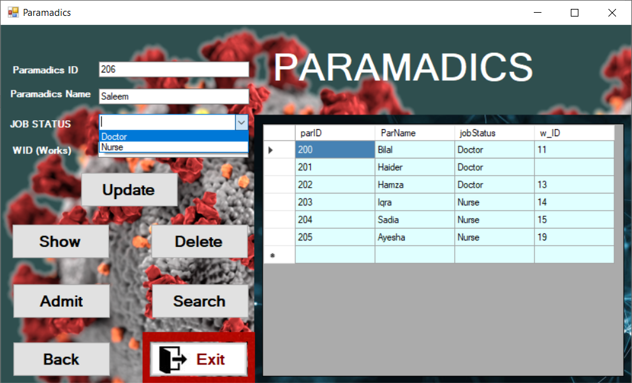

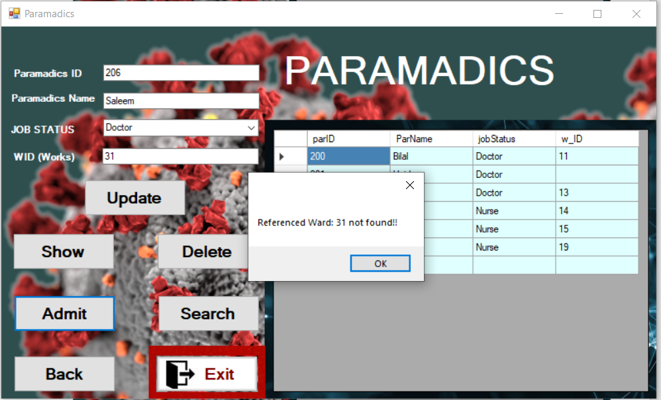

**Admit paramedics**

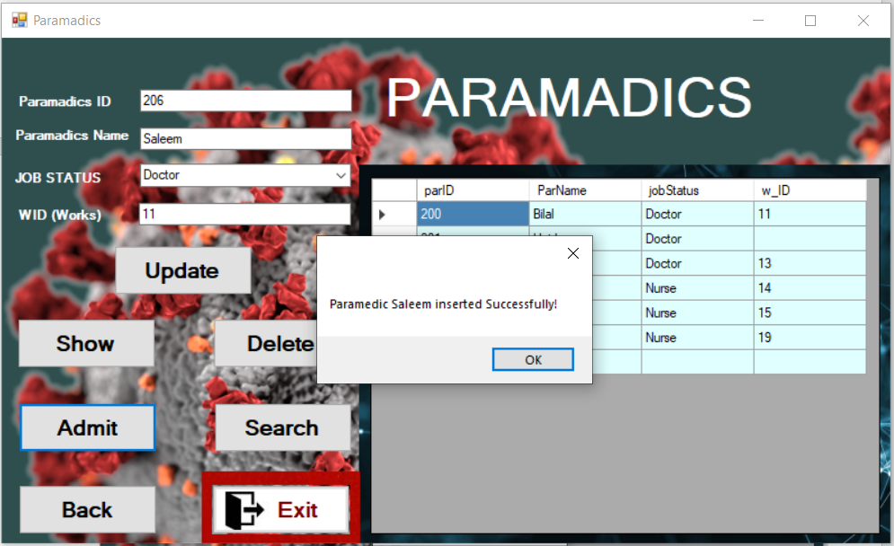

**Paramedics data Updation**

